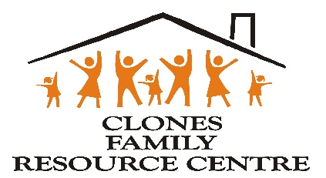

CLONES FAMILY RESOURCE CENTRE CLG

CHILD SAFEGUARDING GUIDING PRINCIPLES, POLICIES AND PROCEDURES

DECEMBER 2024


An Ghniornhaireacht um Leanai agus an Teaghlach Child and Family Agency

Sources
Content in this Family Resource Centre child safeguarding principles, policy and procedures document has been adopted from:

- Children First National Guidance for the Protection and Welfare of Children (2017) “Children First National Guidance”
- Children First Act, 2015

3. Tusla (2018) Child Safeguarding: A guide for Policy, Procedure and Practice
(2018) “Child Safeguarding Guide” which includes six best practice themes.

For further information and guidance on any aspect of this document, please visit the Children First section on www.tusla.ie
CONTENTS
- Glossary and Acronyms Pg 5
- Review History Pg 7
- Family Resource Centre Vision, Values, Codes Pg 9
- Tusla Funding Application and Declaration Agreement in Pg 9
relation to Children First Requirements

CHILD SAFEGUARDING GUIDING PRINCIPLES AND STATEMENT Pg 10-17
- Child Safeguarding Requirements
- What is a Provider?
- Declaration of Guiding Principles
- Child Safeguarding Statement (CSS)
- Child Safeguarding Statement Template
- Commitment to Legislation and Guidance
- Insurance

KEY ROLES IN SAFEGUARDING Pg 18-22
- Named Person
- Designated Liaison Person
- Mandated Persons
- Mandated Assisting
- Relevant Person

RESPONDING TO AND REPORTING CONCERNS Pg 23-32
- Responsibility to Report A Concern
- Mandated Persons Must Report
- Identifying harm and abuse
- Reasonable grounds for concern
- If a child is in immediate danger / emergency
- Reporting a concern (All FAMILY RESOURCE CENTRE Workers and Volunteers)
- Reporting if you are a Mandated Person
- If a DLP decides not to report a concern
- Can I report anonymously?
- Responding to a disclosure from a child
- Retrospective abuse: Responding to adults who disclose childhood abuse
- Talking to parents/guardians about child protection or welfare concerns
- Procedure for addressing allegations of abuse against staff / volunteers
- Protected disclosures ‘whistleblowing’
- Confidentiality, record-keeping and sharing information

WORKING SAFELY WITH CHILDREN AND YOUNG PEOPLE Pg 33-43
- Recruitment and selection of staff and volunteers
- Application form and advertising
- Garda vetting declaration form
- ID and references
- Induction
- Probation
- Supervision and support for staff and volunteers
- Child safeguarding training
- Training resources
- Training records
- Working in partnership (External Organisations)
- Code of behaviour for working with children and young people
- Safe management of activities
- Safe supervision of children and young people
- Accidents and incidents
- Disciplinary procedures

SHARING OUR GUIDING PRINCIPLES, Pg 44-47
INVOLVING PARENTS, CARERS, FAMILIES, CHILDREN AND YOUNG PEOPLE
- Sharing our guiding principles
- Working in partnership
- Communication strategy
- Communication policy
- Guardianship
- Sharing information with primary carers
- Comments and complaints

IMPLEMENTATION, MONITORING, REVIEW AND EVALUATION Pg 48-49
OF GUIDING PRINCIPLES AND CHILD SAFEGUARDING PROCEDURES
- Implementation
- Monitoring and review
- Evaluation

TEMPLATE PROCEDURE FOR APPOINTING A RELEVANT
PERSON Pg 50

TEMPLATE PROCEDURE FOR MAINTAINING A LIST OF MANDATED
PERSONS Pg 51

APPENDICES (See Separate Document 2)

Appendix 1 Schedule of Mandated Persons under the Children First Act 2015
Appendix 2 Definitions and Indicators of Child Abuse
Appendix 3 Child Safeguarding Training Required Sample Form
Appendix 4 Child Protection and Welfare Report Form (CPWRF)
Appendix 5 Retrospective Abuse Report Form (RARF)
Appendix 6 Protection for Persons Reporting Child Abuse Act 1998
Appendix 7 Working in Partnership Checklist
Appendix 8 Sample Policy for Volunteers
Appendix 9 Sample Accident Report Form
Appendix 10 Sample Incident Report Form
Appendix 11 What is Guardianship?
Appendix 12 Parental / Guardian Consent Form
Appendix 13 Children First Self Assessment Template
Appendix 14 Managing Trips Away

GLOSSARY AND ACRONYMS
Child Safeguarding - ensuring safe practice and appropriate responses by staff and volunteers to concerns about the safety or welfare of children, should these arise. Child safeguarding is about protecting the child from harm, promoting their welfare and in doing so creating an environment which enables children and young people to grow, develop and achieve their full potential

Child Safeguarding Statement (CSS) – defined in the Children First Act 2015, this is a statement which includes a written assessment of risk of harm to children and the measures that will be taken to manage any identified risks.

Guiding principles and child safeguarding procedures – previously referred to as child protection and welfare policy and procedures, the procedures an organisation has in place to safeguard children from harm and reduce the risks to children of being harmed.

Child or young person – a person under the age of 18 years, who is not or has not been married.

Child Protection and Welfare Report Form –form for use in reporting suspected or alleged abuse or welfare concerns to Tusla. Available at - https://www.tusla.ie/uploads/content/Child_Protection_and_Welfare_Report_Form_FINAL.docx

Child Safeguarding Guide – Child Safeguarding: A guide for policy, procedure and practice www.tusla.ie

Children First: National Guidance for the Protection and Welfare of Children, “National Guidance” – national, overarching guidance for the protection and welfare of children, published by the Department of Children and Youth Affairs. The current version was published in 2017 www.tusla.ie

Designated Liaison Person (DLP) – a resource to any staff member who has a child protection concern. DLPs are responsible for ensuring that reporting procedures are followed correctly and promptly and act as a liaison person with other agencies (see Children First National Guidance).

Mandated Person – as defined in the Children First Act 2015, Mandated Persons have a statutory obligation to report (i.e. mandatory reporting) concerns which meet or exceed a threshold to Tusla and to cooperate with Tusla in the assessment of mandated reports, where requested to do so

Named Person – a person appointed by an organisation to lead the development of guiding principles and child safeguarding procedures and for ensuring that policies and procedures are consistent with best practice as detailed in the Tusla Child Safeguarding Guide.
Organisation – any department/sector/body/agency/organisation whether private, public or voluntary

Provider – as defined in the Children First Act 2015, ‘means, in relation to a relevant service, a person…
(a) who provides a relevant service, and
(b) who, in respect of the provision of such relevant service:
(i) employs (whether under contract of employment or otherwise) one or more than one other person to undertake any work or activity that constitutes a relevant service
(ii) enters into a contract for services with one or more than one other
person for the provision by the person of a relevant service, or
(iii) permits one or more than one other person (whether or not for commercial or other consideration and whether or not as part of a course of education or training, including an internship scheme) to undertake any work or activity, on behalf of the person, that constitutes a relevant service’.

Retrospective Abuse Report Form (RARF) – form for use in reporting to Tusla
suspected or alleged retrospective abuse or welfare concerns, on adults who allege childhood abuse. Available at - https://www.tusla.ie/uploads/content/Retrospective_Abuse_Report_Form_FINAL.docx See Appendices for this policy.

Relevant Person – as defined in the Children First Act 2015, ‘means a person who is appointed by a provider of a relevant service to be the first point of contact in respect of the provider’s Child Safeguarding Statement’.

Relevant service – as defined in the Children First Act 2015, ‘means any work or activity specified in Schedule 1 [of that Act]’.

Tusla – Tusla is Ireland’s Child and Family Agency, the lead, statutory organisation for safeguarding children in Ireland.

Worker and volunteer – inter alia, any staff, volunteer, member of any board of
management, student, contractor (that have access to children), engaged in an organisation to provide services to children or families

DATE: (insert date)

REVIEW HISTORY

Clones Family Resource Centre (FRC) reviews its Child Safeguarding Guiding Principles, Policies, Procedures, and Child Safeguarding Statement, at least every two years (or sooner if there is an update or change in legislation or national guidance).
Review of the Family Resource Centre’s Child Safeguarding policies etc. is the responsibility of the Named Person*, and ultimately the Voluntary Board of Directors.
This policy was first reviewed on: ________________________
And, then, reviewed by the Named Person on (sign and date):
_____Angela Graham_______________ Date: ________________________
_______________________________ Date: _________________________
________________________________ Date: _________________________
________________________________ Date: _________________________
________________________________ Date: _________________________
*Named person – a person appointed by an organisation to lead the development of guiding principles and child safeguarding procedures and for ensuring that policies and procedures are consistent with best practice as detailed in Tusla Child Safeguarding guide.
The Named Person can also be the Relevant Person and/or Designated Liaison Person—the unique responsibilities of each role must be clearly understood.
See ‘Key Roles in Safeguarding’.

CLONES FAMILY RESOURCE CENTRE

- Vision
Clones Family Resource Centre aims to empower the people of Clones to have an improved quality of life and sense of well-being through encouraging equality, participation, community ownership and a recognition of the diversity of families.

- Mission
This vision is brought about by:
  - Supporting, encouraging and providing opportunities to individuals and families, groups and communities;
  - Networking and working in partnership with community, voluntary and statutory organisations;
  - Maintaining and developing a strong, vibrant organisation that works well together as a team.

- Objectives and Programmes for our Work in the Community

As a Family Resource Centre we work within the five national priorities set by Tusla. These national priorities frame our five local objectives in our work with the people of Clones.

That children, families and the broader community be:
  - Healthy, both physically and mentally.
  - Supported in active learning.
  - Safe from accidental and intentional harm - secure in the immediate and wider physical environment.
  - Economically secure.
  - Part of positive networks of family, friends, neighbours and the community; included and participating in society.

- Activities involving Children and Young People

The following are the activities where there are children or young people involved or potentially involved:

- Beacon Family Support – support is provided to 16 families on an outreach basis in their own homes, outside their homes and / or within the FRC premises;
- Baby and Toddler group – run by a staff member with the help of volunteers;
- Cool Kids Club – run for children from ages 5-12 by a staff member and an assistant;
- Play therapy – one-to-one service for children by contracted therapist;
- Adolescent therapy - one-to-one service for adolescents by contracted therapist;
- Trips away (day trips) with parents, children and staff.

CHILD SAFEGUARDING GUIDING PRINCIPLES AND STATEMENT
Ref: Chapter 4 ‘Responsibilities of Organisations Dealing with Children and Young People’ Children First National Guidance for the Protection and Welfare of Children

Ref: Best Practice Theme 1 in Child Safeguarding: A Guide for Policy, Procedure and Practice pp.10-15

Clones Family Resource Centre’s (“the FRC”) ‘Child Safeguarding: Guiding Principles, Policies and Procedures’ set out the requirements for working with children and young people in accordance with the Children First Act 2015 and Children First National Guidance 2017. The Family Resource Centre’s policies etc. are aligned with National Guidance.
The Family Resource Centre, as a provider of a relevant service, must:
- Undertake an assessment of any potential for harm to a child while availing of the service
- Prepare a written child safeguarding statement specifying the service being provided and the principles and procedures to be observed to ensure as far as practicable, that a child, while availing of the service, is safe from harm
- Appoint a relevant person, named person, designated liaison officer
- Keep a list of Mandated Persons in the FAMILY RESOURCE CENTRE

DECLARATION OF GUIDING PRINCIPLES
Clones Family Resource Centre (FRC) provides the following services/activities to children and young people:

- Beacon Family Support – support is provided to 16 families on an outreach basis in their own homes, outside their homes and / or within the FRC premises;
- Baby and Toddler group – run by a staff member with the help of volunteers;
- Cool Kids Club – run for children from ages 5-12 by a staff member and an assistant;
- Play therapy – one-to-one service for children by contracted therapist;
- Adolescent therapy - one-to-one service for adolescents by contracted therapist;
- Trips away (day trips) with parents, children and staff.
Our Guiding Principles

- Our priority to ensure the welfare and safety of every child and young person who attends our service is paramount

- Our guiding principles and procedures to safeguard children and young people reflects national policy and legislation, and we will review our guiding principles and child safeguarding procedures every two years

- All children and young people have an equal right to attend a service that respects them as individuals and encourages them to reach their potential, regardless of their background

- We are committed to upholding the rights of every child and young person who attends our service, including the rights to be kept safe and protected from harm, listened to and heard

- Our guiding principles apply to everyone in our Family Resource Centre

- Workers and volunteers must conduct themselves according to the Family Resource Centre Code of Behaviour and Conduct, in a way that reflects the principles, ethos and values of our Family Resource Centre.

All Family Resource Centre workers and volunteers must seek training appropriate for their role. They must sign-up to the guiding principles at induction and abide by them.
It is the responsibility of the Named Person, Relevant Person, Designated Liaison Person to ensure all workers and volunteers communicate the principles to children, young people, parents, and guardians where appropriate.

CHILD SAFEGUARDING STATEMENT (CSS)

The Family Resource Centre, as a provider of a relevant service, has an up-to-date Child Safeguarding Statement, which specifies the service being provided and the principles and procedures to be observed to ensure, as far as practicable, that a child availing of the service is safe from harm.

The Family Resource Centre assesses the potential harm to the children and young people using its service(s) by carrying out a risk assessment. This written risk assessment then informs Family Resource Centre’s Child Safeguarding Statement. The Family Resource Centre CSS outlines the policies and procedures which are in place to manage the risks that have been identified.

It is the responsibility of the Named Person to ensure:

- The CSS is displayed prominently in the Family Resource Centre
- A copy of the CSS is provided to all staff and volunteers
- A copy of the CSS is made available to parents/guardians, families etc. if requested
- The CSS is provided to Tusla if requested

See separate Child Safety Statement, which is publicly displayed in Clones FRC Offices.

The Children First Act 2015 defines a ‘provider’ as “a person—
(a) who provides a relevant service, and
(b) who, in respect of the provision of such relevant service—
(i) employs (whether under contract of employment or otherwise) one or more than one other person to undertake any work or activity that constitutes a relevant service,
(ii) enters into a contract for services with one or more than one other person for the provision by the person of a relevant service, or
(iii) permits one or more than one other person (whether or not for commercial or other consideration and whether or not as part of a course of education or training, including an internship scheme) to undertake any work or activity, on behalf of the person, that constitutes a relevant service”.

COMMITMENT TO LEGISLATION AND GUIDANCE
Clones Family Resource Centre (FRC) complies with legislation, guidance and best practice. All Tusla guidance documents can be downloaded from the Tusla website www.tusla.ie Many of the guides are also available in Irish.

RELEVANT LEGISLATION (See www.irishstatutebook.ie)
- Children First Act 2015
- Protections for Persons Reporting Child Abuse Act 1998
- Criminal Justice (withholding of information on offences against children and vulnerable persons) Act 2012
- National Vetting Bureau (Children and Vulnerable Persons) Acts 2012-2016
- Criminal Law (Sexual Offences) Act 2017
- Criminal Justice Act 2006
- Child Care Act 1991
- United Nations Convention on the Rights of the Child.

TUSLA GUIDANCE
- Children First: National Guidance for the Protection and Welfare of Children
- A Guide for the Reporting of Child Protection and Welfare Concerns
- Tusla Child Safeguarding: A Guide for Policy, Procedure and Practice
- Tusla Guidance on Writing a Child Safeguarding Statement
- Tusla Best Practice Principles for Organisations in Developing Children First Training Programmes
- Tusla Children’s Charter
- Tusla Signs of Safety Approach
- Tusla Mandated Assisting Protocol for Tusla Staff.

INSURANCE
The Family Resource Centre Voluntary Board of Directors and DLP are familiar with the terms and conditions of the organisation’s insurance policies—particularly any immediate notifications required by the insurance company if there is an incident or accident.

Insurance Policies Terms and Conditions
Clones FRC VBOM and DLP refer to and are aware of the Terms and Conditions of the Insurance Policies held by the organisation.

KEY ROLES IN CHILD SAFEGUARDING
Ref: Chapter 3 and 4, ‘Mandated Persons’, and ‘Responsibilities of Organisations Dealing with Children and Young People’ of Children First National Guidance for the Protection and Welfare of Children (2017)

Ref: Best Practice Theme 2 in Tusla Child Safeguarding: A Guide for Policy, Procedure and Practice pp.16-21

The role of Named Person, Relevant Person, and Designated Liaison Person (DLP) can be undertaken by the same person - there is no requirement to have different people for each role.

- All workers and volunteers are informed at induction who holds which safeguarding role in the organisation
- The Family Resource Centre keeps a list of Mandated Persons in the organisation – this is held safely by the Designated Liaison Person
- The responsibilities of each role are understood by the respective worker
- All workers and volunteers receive appropriate training relevant to their responsibilities, so they know what to do and who to contact if they have a concern.

NAMED PERSON
In Clones Family Resource Centre (FRC), our named person is:
Angela Graham
- Responsible for leading the development of guiding principles and child safeguarding procedures

- Ensures policies and procedures are consistent with best practice

- Liaises with all key workers and volunteers who have relevant roles and responsibilities

- Assists with the review process.

DESIGNATED LIAISION PERSON (DLP)
Clones Family Resource Centre has appointed a Designated Liaison Person (DLP) who is responsible for ensuring that reporting procedures within the Family Resource Centre are followed, so that child welfare and protection concerns are referred promptly to Tusla.

The Family Resource Centre has also appointed a Deputy Designated Liaison Person (DDLP) who will assume responsibility when the designated liaison person is not available or on leave or if they are directly involved in a concern or incident.

The name and contact details of the DLP and DDLP must be known to all workers and volunteers within the Family Resource Centre, as well as parents and service users.

Our Designated Liaison Person (DLP) is:
Angela Graham
Our Deputy Designated Liaison Person (DDLP) is:
Elaine McDermott

ROLE OF THE DESIGNATED LIAISON PERSON (DLP) / DEPUTY DLP

- Both the Designated Liaison Person and the Deputy are familiar with Children First: National Guidance for the Protection and Welfare of Children 201, associated duties, Family Resource Centre guiding principles and child safeguarding procedures

- The Designated Liaison Person (DLP) and the deputy Designated Liaison Person (DDLP) participate in and complete DLP training when available.

- Receive child protection and welfare concerns from workers and volunteers and consider if reasonable grounds for reporting to Tusla exist

- Consult informally with a Tusla Duty Social Worker if necessary

- Where appropriate, make a formal report of a child protection or welfare concern to Tusla on behalf of the FRC, using the Child Protection and Welfare Report Form

- Inform the child’s parents/guardians that a report is to be submitted to Tusla or An Garda Síochána, unless:
  - Informing the parents/guardians is likely to endanger the child or young person
  - Informing the parents/guardians may place the reporter at risk of harm from the family
  - The family’s knowledge of the report could impair Tusla’s ability to carry out an assessment.

- Record all concerns or allegations of child abuse brought to their attention as well as any action/inaction taken in response to these concerns

- Provide feedback to the referrer, as appropriate

- Ensure that a secure system is in place to manage confidential records

- Act as a liaison with Tusla and An Garda Síochána, as appropriate

- Where appropriate, make joint reports with Mandated Person/s in the FRC.

DLPs are appointed by their organisation to ensure that reporting procedures within the Family Resource Centre are followed.

MANDATED PERSONS

The Children First Act, 2015, outlines who are Mandated Persons in Schedule 2.

The Children First National Guidance 2017 outlines the role of the DLP.

Mandated Persons are required by law, under the Children First Act 2015, to:
(i) report harm of children above a defined threshold to Tusla (i.e. mandatory reporting) and
(ii) assist Tusla, if requested, in assessing a concern which has been the subject of a mandated report (i.e. mandatory assisting)

The Chairperson / Line Manager for the post will inform the worker if they are a Mandated Person at induction. Workers who are Mandated Persons should be made aware of their responsibilities under the legislation. Family Resource Centre Co-ordinators/DLP’s may be both DLP and a Mandated Person if they are listed on Schedule 2 of the Act.

MANDATED ASSISTING
In essential circumstances, where it is determined to be in the best interests of
the child, Mandated Persons can also be mandated to assist Tusla in their assessment of child protection and welfare concerns about children who have been the subject of a mandated report. A Mandated Person must comply with this request.
Mandated assistance may include a request to supply further information over the phone, produce a verbal or written report or attend a meeting.

Information that Tusla shares with another person in the course of carrying out an assessment must not be disclosed to a third party unless Tusla considers it appropriate and authorises in writing that the information may be shared. Failure to comply with this provision is an offence under section 17 of the Children First Act 2015.

See Tusla’s Mandated Assisting Protocol for Tusla Staff which can be accessed at www.tusla.ie

RELEVANT PERSON
The Family Resource Centre has appointed a Relevant Person under the Children First Act 2015.

In Clones Family Resource Centre, our relevant person is:

_________Angela Graham__________________________________
The relevant person is the first point of contact in relation to the Child Safeguarding Statement, and their name and contact details must be included in the Child Safeguarding Statement.

RESPONDING TO AND REPORTING CHILD PROTECTION AND WELFARE CONCERNS
Ref: Chapter 1 and Chapter 5 ‘Dealing with Concerns about a Child – Tusla and An Garda Síochána’ of Children First National Guidance for the Protection and Welfare of Children (2017)

Ref: Best Practice Theme 3 in Tusla’s Child Safeguarding: A Guide for Policy, Procedure and Practice pp. 22-41
Ref: Tusla’s Guide for the Reporting of Child Protection and Welfare Concerns, available on www.tusla.ie.

This section details the Family Resource Centre’s child protection and welfare reporting procedures, including the role of Mandated Persons; information sharing and record-keeping in relation to child protection and welfare concerns; confidentiality; responding to children who disclose abuse; responding to adult disclosures of childhood abuse; and the FRC’s procedures for responding to allegations of abuse against staff.

RESPONSIBILTY TO REPORT A CONCERN
- All child protection concerns should be brought to the attention of the Designated Liaison Person without delay. If the child is in immediate danger, call the Gardaí.

- The responsibility to report child protection or welfare concerns applies to everyone working with children or family members.

- Confidentiality should never be used as a reason not to report a child protection concern.

- The safety and wellbeing of the child takes priority over all other considerations. If you ignore what may be symptoms of abuse, it could result in ongoing harm to the child.

IDENTIFYING HARM AND ABUSE
Please see Appendix 1 for categories, signs and indicators of child abuse and neglect.
Children First National Guidance defines four categories of abuse: neglect, emotional abuse, physical abuse and sexual abuse. A child/young person may be subjected to one or more forms of abuse at any given time.
Cyberbullying should also be considered. Please see Children First National Guidance for more information.
Children First Act 2015 defines “‘harm’ as, in relation to a child:
(a) assault, ill-treatment or neglect of the child in a manner that seriously affects or is likely to seriously affect the child’s health, development or welfare, or
(b) sexual abuse of the child, whether caused by a single act, omission or circumstance or a series or combination of acts, omissions or circumstances, or otherwise”.

REASONABLE GROUNDS FOR CONCERN
You should always inform the DLP in the Family Resource Centre if you have reasonable grounds for concern that a child may have been, is being, or is at risk of being abused or neglected.
It is not necessary for you to prove that abuse has occurred to report a concern. All that is required is that you have reasonable grounds for concern. It is Tusla’s role to assess concerns that are reported to it. If you report a concern, you can be assured that your information will be carefully considered with any other information available and a child protection assessment will be carried out where enough risk is identified.

Reasonable grounds for a child protection or welfare concern include:
- Evidence, for example, of an injury or behaviour that is consistent with abuse and is unlikely to have been caused in any other way.

- Any concern about possible sexual abuse.

- Consistent signs that a child is suffering from emotional or physical neglect.

- A child saying or indicating by other means that he or she has been abused.

- Admission or indication by an adult or a child of an alleged abuse they committed.

- An account from a person who saw the child being abused.

IF A CHILD IS IN IMMEDIATE DANGER / EMERGENCY SITUATION
- If you think the child is in immediate danger, you must contact An Garda Síochána (the police)

- In an emergency, where you believe the child is at risk of immediate harm, you should contact the DLP first, failing that, contact local Tusla Social Work Duty Service without delay before making a written report.

- Mandated reporters can access Tusla's emergency out-of-hours social work service. If you are a mandated reporter and wish to report a case of child harm to Tusla, you can contact out-of-hours social work service on 0818 776 315, 6pm and 6am every night and between 9am and 5pm on Saturdays, Sundays and bank holidays.

- Under no circumstances should a child be left in a situation that exposes him or her to harm or risk of harm if waiting for an intervention.

- If you are a Mandated Person, you must follow up with a mandated report to Tusla within three days of the emergency.

REPORTING A CONCERN (ALL FAMILY RESOURCE CENTRE WORKERS AND VOLUNTEERS)

- Regardless of how a concern comes to a worker or volunteer’s attention, it must be reported to the Designated Liaison Person without delay.

- If a worker/volunteer receives information regarding a suspicion of child abuse from a third party this must be reported to the Designated Liaison Person who will then consult appropriately with Tusla Duty Social Work.

- If you are a Mandated Person who also holds the role of designated liaison person, you must fulfil your statutory obligations to report a concern as a Mandated Person.

- The Designated Liaison Person, in consultation with the worker/volunteer who has raised a concern, will decide if reasonable grounds for concern exist.

- If the DLP is unsure if a child protection concern meets the reasonable grounds for concern, they should contact Tusla Duty Social Work for informal advice and guidance.
Number of Local Tusla Duty Social Work Team(s):

(insert the local telephone number for your social work area/s )

Number of Local Garda Station: XXXXXXXXX
(Also in an emergency you can ring 999)

For social work numbers in your area visit:
https://www.tusla.ie/children-
first/contact-a-social-worker3/

- Any query or concern in relation to children out of hours should be reported immediately to An Garda Siochana.

- The DLP will report child protection and welfare concerns by completing the Child Protection and Welfare Report Form(CPWRF) which is available on the Tusla web-portal. DLP’s should register on the Tusla web Portal and make reports electronically. For details on how to register see https://www.tusla.ie/children-first/web-portal/ (For details of the CPWRF see Appendix 4)

- In the event of an emergency and the unavailability of a Tusla Duty Social Worker, the DLP will contact the police, An Garda Síochána.

- If a concern relates to the DLP, reports should be made to the Chairperson.

- If a concern is about a worker or volunteer of the Family Resource Centre, the procedure for addressing allegations of abuse against staff / volunteers should be followed.

- The Chairperson of the Voluntary Board of Directors may be informed when a report has been made by a DLP to Tusla. Information which identifies the child or family is only shared on a strictly ‘need to know’ basis.

- The DLP will record factual details of the concern, the decisions and actions taken. These records will be held securely and confidentially.

REPORTING IF YOU ARE A MANDATED PERSON
- If you are a Mandated Person you must report a concern without delay. You may do this with the DLP in the Family Resource Centre or independently of the DLP. Guidance for Mandated Persons on the thresholds at which, or above which, they have a statutory obligation to report the concern under the Children First Act 2015.

- As a Mandated Person, if you have concerns you have a legal obligation to make a report as below.
“…where a Mandated Persons knows, believes or has reasonable grounds to suspect, on the basis of information that he or she has received, acquired or becomes aware of in the course of his or her employment or profession as such a Mandated Person, that a child—
(a) has been harmed,
(b) is being harmed, or
(c) is at risk of being harmed,
he or she shall, as soon as practicable, report that knowledge, belief or suspicion, as the case may be, to Tusla.”
Also, Section 14(2) of the Children First Act 2015 places obligations on Mandated Persons to report any disclosures made by a child:
“Where a child believes that he or she–
(a) has been harmed,
(b) is being harmed, or
(c) is at risk of being harmed,
and discloses this belief to a Mandated Person in the course of a Mandated Person’s employment or profession as such a person, the Mandated Person shall, as soon as practicable, report that disclosure to Tusla.”

- Mandatory reporting cannot be discharged by a DLP on your behalf. Mandated Persons can, however, make a joint report with a DLP.

- Where a Mandated Person has a concern that they believe does not reach the threshold for a mandated report, they should consider whether the concern meets reasonable grounds for concern, and they should report the concern to their DLP.

- If the DLP does not wish to report to Tusla, you, as a Mandated Person, should proceed with making a report and inform the DLP that a report under the Children First Act 2015 has been made. The Protections for Persons Reporting Child Abuse Act 1998 will apply in this instance. See Appendix 6 for an overview of this Act.

- If a child protection concern has come to the attention of several Mandated Persons, the report may be submitted jointly by them.

- Mandated Persons should inform the DLP in the Family Resource Centre if they have made a report.

MAKING A MANDATED REPORT OUT OF HOURS
Mandated reporters can now access Tusla's emergency out-of-hours social work service. If you are a mandated reporter and wish to report a case of child harm to Tusla, you can contact our out-of-hours social work service on 0818 776 315 between 6pm and 6am every night and between 9am and 5pm on Saturdays, Sundays and bank holidays.
If you cannot contact Tusla and have an immediate concern about the safety of a child, please contact An Garda Síochána.

IF A DLP DECIDES NOT TO REPORT A CONCERN
If, as a designated liaison person, you decide not to report a concern to Tusla, the following steps should be taken:
- The reasons for not reporting should be recorded.
- Any actions taken as a result of the concern should be recorded.
- The worker or volunteer who raised the concern should be given a clear written explanation of the reasons why the concern is not being reported to Tusla.
- The worker or volunteer should be advised that if they remain concerned about the situation, they are free to make a report to Tusla or An Garda Síochána.
- The worker or volunteer who raised the concern should also be reassured that if they do choose to further pursue the matter, they are covered by the Protections for Persons Reporting Child Abuse Act 1998.

CAN I REPORT ANONYMOUSLY?
Workers and Designated Liaison Persons cannot report anonymously. Similarly, Mandated Persons may not report anonymously as they are obliged to report by law.

RESPONDING TO A DISCLOSURE FROM A CHILD
You should deal with disclosures of abuse sensitively and professionally.
The following approach is suggested as best practice for responding to a disclosure.
Where a child/young person discloses abuse, the reporting procedure should be followed.

N.B. Think before you promise anything – do not make promises you cannot keep.

At the earliest possible opportunity:
- Record in writing, in a factual manner, what the child/young person has said, including, as far as possible, the exact words used by the child/young person
- Ensure that the child understands the procedures that will follow
- Inform the DLP immediately per reporting procedures
- Treat the information confidentially

- React calmly, listen carefully and attentively
- Take the child seriously
- Reassure the child that they have taken the right action in talking to you
- Do not promise to keep anything secret
- Ask questions for clarification only
- Do not ask leading questions
- Avoid asking about intimate details or suggesting that something else may have happened other than what you have been told
- Check back with the child that what you have heard is correct and understood
- Do not express any opinions about the alleged abuser

Things to say | Things not to say
I want to listen to what you have to say | Wait until I get my manager, so you can tell them too?
I am going to do my best to help you | I can’t do anything
You did the right thing by telling me, this is what I am going to do next … | I can’t believe it, I’m shocked
You are not to blame | This is your fault
Is there anything else you want to share? | Don’t tell me any more

RETROSPECTIVE ABUSE: RESPONDING TO ADULTS WHO DISCLOSE CHILDHOOD ABUSE
- The requirement to report retrospective concerns should be made explicit to the client, prior to commencement of work, for example in a therapy or counselling contract.

- If a worker/volunteer receives a disclosure from a client or service user that they were abused as a child (i.e. a disclosure of retrospective abuse), you must report this information to Tusla using a Retrospective Abuse Report Form (RARF) as there may be a current or potential risk to children from the person against whom there is an allegation.

- If you are unsure about whether to report or not, consult with your DLP or the Tusla Duty Social Work.

- Guidelines for completing a RARF can be found in Appendix 5, and on the Tusla website: www.tusla.ie/children-first/publications-and-forms/

TALKING TO PARENTS/GUARDIANS ABOUT CHILD PROTECTION OR WELFARE CONCERNS
- It is usually good practice to tell the most appropriate parent/guardian in the family that you are making a report.

- This means that the family is fully informed about the services they are being referred to and understand what information professionals are passing on and why. However, there are some exceptions to informing the family (see below).

- You do not need to tell the family that a report is being made, if:
- By doing so, the child will be placed at further risk
- Where the family knowing about the report could affect Tusla’s ability to carry out a risk assessment
- You believe that doing so would place you at risk of harm from the family.

PROCEDURE FOR ADDRESSING ALLEGATIONS OF ABUSE AGAINST STAFF / VOLUNTEERS

An allegation of abuse may relate to a person who works with children who has:
- Behaved in a way that has or may have harmed a child/young person.
- Possibly committed a criminal offence in relation to a child/young person.
- Behaved towards a child/young person or children/young people in a way that
indicates they may pose a risk of harm to a child/young person.

The Family Resource Centre has a dual responsibility in respect of both the child/young person and the worker/volunteer. There are two separate procedures to be followed:
- The Designated Liaison Person will deal with the child welfare or protection concern procedure
Note: Where an allegation of abuse is made against the Designated Liaison Person, the Deputy Designated Liaison Person will deal with the concern.

- A member of the Voluntary Board of Directors (Employer), ideally a member of the Staffing Sub-group and / or the Chairperson, will deal with the allegation against the staff member / volunteer i.e. will deal with the employment aspect.

- Legal and/or HR advice should be sought by the Board if in doubt.
- The same person should not have responsibility for dealing with the child protection reporting procedure and the employment/contractual issues.
- If an allegation is made against a worker/volunteer the Family Resource Centre must ensure that everyone involved is dealt with appropriately and in accordance with:
  - the Family Resource Centre’s guiding principles and child safeguarding procedures
  - the rules of natural justice
  - relevant employment law.

PROCEDURE FOR ADDRESSING ALLEGATIONS OF ABUSE AGAINST STAFF / VOLUNTEERS
First priority is for the safety of the child/young person; the Chairperson and / or DLP must ensure no child or young person is exposed to unnecessary risk. The FAMILY RESOURCE CENTRE will put in place necessary protective measures. This is not a presumption of guilt.

Child welfare or protection concern  - If an allegation against a worker or volunteer is received, it will be dealt with promptly and strictly in accordance with agreed reporting procedures to the DLP  - The DLP will alert the Chairperson and/or member of Staff Liaison Sub-group that a concern has been raised  - The decision to make a formal report will be based on reasonable grounds for concern  - The DLP will consult with Tusla Duty Social Worker and complete the Child Protection and Welfare Report Form as required  - Parents/guardians should be informed of any action planned while having regard to the confidentiality and safety of all concerned including the worker / volunteer. | Employment  - Once alerted by the DLP of an allegation, the Chairperson will privately inform the worker/volunteer who the allegation is against of (1) the fact that an allegation has been made against them and (2) the nature of the allegation  - The FRC will ensure that the principles of ‘natural justice’ apply throughout the process  - All stages of the process must be recorded  - The worker/volunteer should be offered the option to have representation  - The worker/volunteer will be afforded an opportunity to respond to the allegation and should be informed that any response will be noted in any subsequent report to Tusla or An Garda Síochána  - An investigation will take place into the allegation(s) as soon as possible and in accordance with the FAMILY RESOURCE CENTRE’s disciplinary and grievance procedures  - The FAMILY RESOURCE CENTRE will ensure that no other children or young people are put at risk during this period. This may include any of the following:  - suspension of duties pending the outcome of an investigation  - re-assignment of duties that do not involve children and young people  - working under increased supervision during the period of the investigation  - The FRC will inform the person against whom the allegation has been made of the outcome of the investigation as quickly as possible  - The FRC work in consultation with Tusla and An Garda Síochána on what action(s) should be taken.

PROCEDURE FOR ADDRESSING ALLEGATIONS OF ABUSE AGAINST BOARD MEMBERS AND/OR WHERE ALLEGATIONS HAVE BEEN MADE OUTSIDE OF THE FRC
All of the points and steps outlined above for staff / volunteers apply with the exception of the section titled “Employment.” The following steps will be taken in the case of a Board member:

- The Chairperson, or if the allegation is against the Chairperson the Vice-Chairperson, will be informed about the allegation.
- The Chairperson will seek a meeting with the Board member against whom the allegation has been made when advised by Tusla that they can do so.
- The Board member will be asked, without prejudice, to step down off the Board temporarily until the matter has been fully investigated by Tusla / An Garda Síochána.
- The Board member will be asked not to approach the Chair / Vice-Chair or any member of the staff in relation to the matter other than by arrangement.
- The Board member will be asked not to represent the FRC in any way.
- A record will be kept in a confidential place of this meeting and any subsequent meetings.
- The Board will be informed at a Board meeting that the Board member is stepping off the Board temporarily for personal reasons and this will be minuted.
- Following advice by Tusla that they have completed their investigation and that they have no concerns, the Board member will be invited to rejoin the Board.
- Where Tusla finds the allegation to be true, the Board member will be invited to a meeting and asked to resign from the Board. This will subsequently be reported to the Board with personal reasons being cited.
- Where the Board member refuses to resign from the Board, they will be advised that the matter will be taken up with the Board.

PROTECTED DISCLOSURES ‘WHISTLEBLOWING’
Workers/volunteers in Clones Family Resource Centre are made aware of the appropriate authorities outside the Family Resource Centre to whom they should report if they are inhibited, for any reason, in reporting an incident internally or where they are dissatisfied with the internal response. Please see the Family Resource Centre’s policy on Protected Disclosures.

CONFIDENTIALITY, RECORD-KEEPING AND SHARING INFORMATION
Clones Family Resource Centre is committed to peoples’ rights to data protection and confidentiality. However, in relation to child safeguarding the Family Resource Centre undertakes that:
- Information in relation to child safeguarding will only be shared on a ‘need to know’ basis within the Family Resource Centre and will always be in the best interest of the child.
- No undertakings regarding secrecy can be given. Those working with children/young people and families and in adult services should make this clear to parents/guardians and to the child/young person.
- The Family Resource Centre will co-operate with Tusla on proportionate sharing of records where a child welfare or protection concern arises. See Tusla’s Mandated Assisting Protocol.
- Records should be factual and include details of contacts, consultations and any actions taken.

- Records on child protection concerns, allegations and disclosures are kept securely and safely within the Family Resource Centre by the DLP as per data protection policies.

- Access to these records will be managed by the Designated Liaison Person or person delegated and the Chairperson.

WORKING SAFELY WITH CHILDREN AND YOUNG PEOPLE
Ref: Chapter 4 ‘Responsibilities of Organisations Dealing with Children and Young People’ of Children First National Guidance for the Protection and Welfare of Children (2017)

Ref: Best Practice Theme 4 in Tusla Child Safeguarding: A Guide for Policy, Procedure and Practice pp. 42-62

SAFE RECRUITMENT OF STAFF AND VOLUNTEERS

Clones Family Resource Centre will ensure best practice in the recruitment of staff and volunteers.

APPLICATION FORM AND ADVERTISING
An application form must be filled out for all positions in the Family Resource Centre, whether the position is paid or on a voluntary basis. For volunteers, the Application Form is combined with a Declaration Form (available on file).
Advertising for positions, paid and voluntary will be done as widely as possible and in a fair, open and transparent manner.

GARDA VETTING
Clones Family Resource Centre will ensure that it fully complies with all the requirements of this legislation. Under the National Vetting Bureau (Children and Vulnerable Persons) Acts 2012–2016, it is compulsory for employers to obtain vetting disclosures in relation to anyone (whether paid or unpaid) who is carrying out relevant work with children or vulnerable adults. Family Resource Centres should contact the FRC Garda Vetting Officer in Ballymote FRC (071 9197818) for further details.

All prospective candidates consent to Garda Vetting if they successfully move to the conditional stage of offer. The process of Garda Vetting a successful candidate must be completed prior to that person commencing work with the organisation.

SELECTION AND INTERVIEW PROCESS
Staff will be selected by a panel of at least two or more representatives through an interview process. Volunteers with the Family Resource Centre will also be required to go through an informal interview process with the Centre Co-ordinator and a member of the Voluntary Board of Directors. Any person that is deemed to constitute a risk to children or young people will not be engaged / employed.

Some of the exclusions include:
- Any child abuse related convictions.
- Refusal to sign the application and / or declaration form.
- Insufficient documentary evidence of identity.
- Concealing information on one’s suitability for working with children.

ID AND REFERENCES
Two forms of identification, including one form of photo I.D. with a signature (e.g. passport or driving licence) must be provided by staff and volunteers. Contact details for two referees, who are not family members, must be provided. References will be sought in writing or by telephone and will be followed up by telephone or personal visit as appropriate. See Appendix 8 for a Sample Reference Form for Volunteers.

SIGN-OFF
All appointments must be approved by the Voluntary Board of Directors, not by any individual member of the Family Resource Centre. Tusla must be informed of appointments funded by it.

INDUCTION
- New staff and volunteers in Clones Family Resource Centre must undertake an induction process that includes information on the policies and procedures of the Centre particularly this child safeguarding policy.
- All volunteers and staff that work with the Family Resource Centre are required to sign and abide by child safeguarding policy and procedures.
- All staff members and volunteers will be provided with clear job descriptions that outline their roles and responsibilities.
- Staff who are Mandated Persons will be informed of this by the Relevant Person.
- If the volunteers or staff members are external to the Centre, then it will be agreed beforehand with their respective employer or Line Manager what policies and procedures they will be governed by as well as the level of responsibility both organisations have in implementing the placement agreement.
- Appropriate induction will be an integral part of each agreement.
- Where the Family Resource Centre is managing an activity / programme in the Centre in partnership with another organisation (or organisations), a contract will be drawn up and agreed with the relevant organisation(s).
- This contract will include procedures for the safe management of staff and volunteers for the particular, co-managed activity / programme.

PROBATION
Staff and volunteers will complete a probationary / trial period of at least three months. During this time, their interaction with children and young people and their willingness to abide by, and actively implement, child safeguarding policy and procedures will be assessed by their Line Manager.

SUPERVISION AND SUPPORT FOR STAFF AND VOLUNTEERS
- The Co-ordinator and/or Line Manager of the Family Resource Centre provides support and supervision for staff at least every six weeks.
- All staff members have regular access to the Staff Liaison Sub-group of the Voluntary Board of Directors. Meetings are scheduled at the beginning of each year.
- Staff team meetings are held monthly and volunteers are invited to attend as appropriate.
- Staff appraisal meetings take place annually and / or in line with the terms of staff contracts and are overseen by the Staff Liaison Sub-group of the Voluntary Board of Directors. Child protection and the promotion of child welfare will be addressed during the appraisal meeting.
- Volunteers are supported and supervised by the Co-ordinator/ Line Manager.
- Volunteers will be facilitated to meet at least annually, or more often as required, to review their performance and discuss any emerging issues.
- Appropriate support and supervision structures for staff / volunteers from an external organisation will form part of their placement agreement.
- The Terms of Reference for all working groups / sub-groups of the Voluntary Board of Directors will include a reference to the need to abide by this child safeguarding policy.

CHILD SAFEGUARDING TRAINING
- The Family Resource Centre will assess its child safeguarding training needs on a regular basis and seek to provide training on Children First relevant to the role of the worker or volunteer in the Family Resource Centre (see Appendix 3) Family Resource Centre Management is responsible for ensuring that all relevant workers and volunteers are trained in the recognition of the signs of abuse, understand their responsibilities to safeguard children and know the procedures to follow.

Training Resources
- Universal e-learning training programme called ‘Introduction to Children First’ developed by Tusla, Department of Children and Youth Affairs (DCYA) and HSE.

- Tusla's Best Practice Principles for Organisations in Developing Children First Training Programmes.

- Tusla Children First Information and Advice Officers are available to liaise with voluntary and community organisations and provide advice and guidance on Children First. They can also help with any queries about child protection and welfare training. Contact details for your local Children First Information and Advice Officer can be found on www.tusla.ie

Training Records
The Family Resource Centre will keep a log of what safeguarding training workers and volunteers have received. This log is maintained by the Named Person / Designated Liaison Person and records the following details:
- Date and name of training programmes delivered
- Names of worker/volunteers who attended and their position within the
organisation
- Details of workers/volunteers who did not receive training but need to complete it
- Number of workers/volunteers trained
- Training programmes completed by each worker/volunteer (e.g. induction into the organisation’s guiding principles and child safeguarding procedures, child safeguarding training, DLP training, etc.)
- The names of the trainers who delivered the programme and the organisation
- A signed receipt of all workers/volunteers who have been given a copy of the organisation’s declaration of guiding principles and child safeguarding procedures (can be done at induction or in-house training).

WORKING IN PARTNERSHIP (EXTERNAL ORGANISATIONS)
- When using facilities or services provided by another organisation, Family Resource Centre workers / volunteers will clarify and agree which organisation’s reporting procedures for child protection or welfare concerns will be followed.

- The Family Resource Centre will clarify the nature of its relationship with the other organisation immediately – particularly in relation to management of staff and volunteers and agreement of the required policies and procedures to ensure a safe environment where the welfare of the child is paramount. The ‘Working in Partnership’ checklist, (based on child safeguarding best practice themes) in Appendix 7, can be used to facilitate this agreement.

- Where students, scheme participants or people on work placements are engaged by the Family Resource Centre, the Designated Liaison Person will explore with their Employer / Line Manager child safeguarding policies and procedures that the organisation operates under and will agree who has responsibility for addressing any child protection or welfare issue that might arise.

- Codes of Behaviour will be discussed to identify any variances in work practices and to agree a shared approach as part of the placement agreement.

- Complaints procedures / how to address allegations of inappropriate behaviour will also be part of this discussion and both organisations will have agreed procedures in place regarding information sharing, should such issues arise.

- Where the Family Resource Centre is co-managing an activity / programme in the Family Resource Centre, a written contract will be agreed with the other organisation(s). The contract will stipulate the agreed policies and procedures that are required to ensure the safe management of the activity / programme and will identify the Designated Liaison Person to lead any child protection or welfare concern that may arise.

- Information sharing / record keeping protocols will also be agreed in relation to each procedure outlined in the contract.

FRCS WORKING IN PARTNERSHIP WITH EXTERNAL ORGANISATIONS.
- When using facilities or services provided by another organisation, Family Resource Centre workers / volunteers will clarify and agree which organisation’s reporting procedures for child protection or welfare concerns will be followed.

- The Family Resource Centre will clarify the nature of its relationship with the other organisation immediately – particularly in relation to management of staff and volunteers and agreement of the required policies and procedures to ensure a safe environment where the welfare of the child is paramount. The ‘Working in Partnership’ checklist, (based on child safeguarding best practice themes) in Appendix 7, can be used to facilitate this agreement.

- Where students, scheme participants or people on work placements are engaged by the Family Resource Centre, the Designated Liaison Person will explore with their Employer / Line Manager child safeguarding policies and procedures that the organisation operates under and will agree who has responsibility for addressing any child protection or welfare issue that might arise.

- Codes of Behaviour will be discussed to identify any variances in work practices and to agree a shared approach as part of the placement agreement.

- Complaints procedures / how to address allegations of inappropriate behaviour will also be part of this discussion and both organisations will have agreed procedures in place regarding information sharing, should such issues arise.
- Where the Family Resource Centre is co-managing an activity / programme in the Family Resource Centre, a written contract will be agreed with the other organisation(s). The contract will stipulate the agreed policies and procedures that are required to ensure the safe management of the activity / programme and will identify the Designated Liaison Person to lead any child protection or welfare concern that may arise.

- Information sharing / record keeping protocols will also be agreed in relation to each procedure outlined in the contract.

External Groups / organisations renting a space / room in your FAMILY RESOURCE CENTRE

If the external group is using your facilities outside the hours your service operates (for example: your service operates 9am to 6pm and the external group is using your facilities after 6pm) you should ensure, where applicable:

- That the external organisation understands that they are fully responsible for managing their own activities

- They have appropriate insurance cover and have provided copy of same.
- That the external group is aware of Children First and has appropriate policies in place (if applicable)

- That the external group has informed parents/guardians of their agreement with your service and that there is a clear distinction between the two services (if applicable)
If the external group is using your facilities during the hours that your service operates you should ensure, where applicable:

- That you include this factor when carrying out a risk assessment of harm that may occur to the children availing of your service (if you are a provider of a relevant service under the Children First Act, 2015) when an external group is also using the facilities;

- That you have adequate policies and procedures in place to ensure the safeguarding of children availing of your service when an external group is also using the facilities;

- The group is aware of your guiding principles and child safeguarding procedures;

- The group has appropriate insurance cover;

- The group is aware of your organisation’s principles and values;

- The group is aware of Children First and has confirmed that they have appropriate policies in place;

- There is a signed agreement between the two parties.

If the group is delivering a service to children and families in partnership with your organisation, then it is essential that governance issues are clarified and agreed prior to the service commencing.

CODE OF BEHAVIOUR FOR WORKING WITH CHILDREN AND YOUNG PEOPLE
Clones Family Resource Centre is committed to providing equal opportunities for all children and young people regardless of their gender, age, culture, disability, religious beliefs, family status, sexual orientation or membership of the Traveller community.

Clones Family Resource Centre promotes a child-centred approach to creating a safe environment for children and young people. Staff and volunteers are provided with clear good practice guidelines on what is acceptable behaviour when working with children and young people.

Workers and volunteers in this Family Resource Centre have a responsibility to promote children’s rights.

WORKERS AND VOLUNTEERS WILL:
- Create a safe, inclusive, accessible environment
- Treat children and young people with dignity, sensitivity and respect
- Listen to and value children’s opinions and beliefs
- Make sure that children know the Family Resource Centre’s rules about behaviour
- Include children in appropriate decision making
- Help children to be safe, happy and have as much fun as possible
- Enable children to regard their bodies as their own property
- Give written information about the Family Resource Centre to children and their parents / carers
- Know about the principles and practices of child safeguarding, data protection, including their legal duties

- Respect children’s privacy in bathrooms and in changing rooms
- Sensitively ensure that children know about the child safeguarding policy

- Always respond to complaints or allegations

- Help children realise the difference between confidentiality and secrecy

- Use encouragement to positively develop confidence and self-esteem

- Be sensitive to the fact that some children are more vulnerable and have special needs

- Facilitate the young people to draw up an Anti-bullying Code of behaviour that will be followed while they are in the Centre or involved in any activities with the FAMILY RESOURCE CENTRE. Cyberbullying should also be discussed.

WORKERS AND VOLUNTEERS WILL NOT:
- Bully children

- Spend excessive amounts of time alone with children away from others. Meetings with individual children or young people will take place as openly as possible

- Shout at or show aggression towards children
- Subject children to any form of verbal, physical, emotional or sexual abuse

- Will not engage in sexually provocative games or making suggestive comments, even in fun

- Exclude children from groups or activities because of difference

- Favour one child or children over others

- Have inappropriate physical contact with children

- Tell jokes of a racist, sexual or derogatory nature

- Refuse to act on a child welfare concern about someone in their care
- Engage in slagging or joking that belittles children.

SAFE MANAGEMENT OF ACTIVITIES
- The Family Resource Centre will minimise opportunities for accidents or harm to children and young people by ensuring that its facilities are fit-for-purpose, and in compliance with health and safety regulations before planning and running activities.

- The Family Resource Centre will keep an appropriate record of participants when running activities including emergency contact telephone number, address, individual needs, and medical conditions (if disclosed and relevant).

- The Family Resource Centre will keep up-to-date records of attendance, accidents (accident records should be reviewed regularly, and any unusual patterns reported to senior management), incidents, consent forms, any complaints or grievances.

Family Resource Centre workers/volunteers will consider the following if organising activities and events:

- Appropriate transport arrangements will be made for all activities
- Activities will be age appropriate
- Registration forms, parental consent forms etc. will be provided as required
- Incident, and accident report forms, safety procedures will be used to ensure the safety and protection of children and young people
- There is insurance, and insurance companies are notified immediately if there is an incident or accident
- Clear lines of communication between organisers and parents/guardians regarding attendance, location, drop-off and pick-up, duration of activities will be agreed.

SAFE SUPERVISION OF CHILDREN AND YOUNG PEOPLE
Children/young people are less likely to experience accidents or incidents if they are supervised properly. Activities should be organised to maximise participation, fun and learning in a way that minimises risk.

Ensure that:
- A work schedule is displayed so that everyone knows who is on duty or volunteering in an activity;

- Children/young people are not left unattended;

- Adequate numbers of workers/volunteers are available to supervise the activities (best practice would indicate that there are male and female workers/volunteers present to supervise coeducational activities);

- Workers/volunteers always know where children/young people are and what they are doing;

- Any activity using potentially dangerous equipment has constant adult supervision;

- Dangerous behaviour is never allowed.

PHYSICAL CONTACT
- Physical contact will be in response to the need of the child and not the need of the adult.

- Physical contact should always be with the child’s permission – resistance from the child will be respected.

- Breasts, buttocks and groin should always be avoided.

- Physical contact should be open and not secretive.

- Any physical contact should be governed by the developmental stage of the child.

- Tasks of a personal nature will only be undertaken with the utmost of discretion in an emergency; for very young children or disabled children and always with the full understanding and consent of the parents.

ONLINE SAFETY

Comprehensive procedures will be put in place to minimise the risk to children and young people from inappropriate use of the internet, social media, photographic and digital recording devices by staff/volunteers and young people involved in FRC activities. (see appendices 16)

ACCIDENTS AND INCIDENTS
Clones Family Resource Centre has a Health and Safety Statement in line with Safety, Health and Welfare at Work Act 2015 that includes a risk assessment of each area of operation. Procedures to follow in the event of an accident or incident are below. Incidents must be recorded separately to an accident. See Appendix 10 and 11 for sample forms.

PROCEDURES
- All accidents in the Family Resource Centre must be reported to the Health and Safety officer, Angela Graham, who has participated in First Aid training / refresher training in the previous two years.
- All accidents and incidents must be recorded using the Centre’s respective Incident Report Form and Accident Report Form.
- If a child has an accident, the primary carers are always informed of the nature of the accident and any treatment given.
- The location of the First-aid boxes is known to all staff members / volunteers and they are checked and re-stocked regularly.
- Children and young people are advised of any possible health and safety risks when participating in any activities / programmes in the Centre .
- Where trips are made ‘off site’, requirements in relation to having staff/volunteers trained in first aid will be an integral part of planning.
- Trips away must be planned for, and managed. See 4.3.9 ‘Managing trips away If the activities involve use of off-site facilities’ in the Tusla Child Safeguarding Guide for Policy, Procedure and Practice www.tusla.ie (See Appendices 14)
- External organisations that the Family Resource Centre works with are obliged to provide proof that they have adequate public liability insurance.

DISCIPLINARY PROCEDURES
All workers and volunteers must be aware of, and familiar with the FAMILY RESOURCE CENTRE’s Disciplinary and Grievance procedures.

SHARING OUR GUIDING PRINCIPLES, CHILD SAFEGUARDING STATEMENT, CHILD SAFEGUARDING PROCEDURES INVOLVING PARENTS, CARERS, FAMILIES, CHILDREN AND YOUNG PEOPLE
Ref: Best Practice Theme 5 in Tusla’s Child Safeguarding: A Guide for Policy, Procedure and Practice pp. 63-71

SHARING OUR GUIDING PRINCIPLES
- Parents/guardians, children and young people should be made aware of the Family Resource Centre’s guiding principles, child safeguarding procedures, and Child Safeguarding Statement on initial contact with the Family Resource Centre

- Codes of Behaviour, Code of Conducts, including the Family Resource Centre’s anti-bullying policy will be communicated to all

WORKING IN PARTNERSHIP
- Children and young people are made aware of their right to be protected, consulted and treated with respect.
- When communicating with parents/guardians, families, children and young people, workers and volunteers should be mindful of possible literacy issues, language barriers and communication differences.
- Workers and volunteers should encourage the active participation of children and young people in decision making in a manner which is appropriate to their age.
- Family Resource Centre workers and volunteers will check that children/young people understand that they are free to approach any worker/volunteer if they are worried about something.
- Children will be unconditionally respected and will be heard, listened to and taken seriously in the Centre.
- Children will be appropriately consulted on the development of codes and policies including anti-bullying.
- Where possible and depending on resources, age appropriate workshops will be facilitated to maximise their participation.
- Family Resource Centre workers and volunteers will seek feedback from parents/guardians informally and via formal review and evaluation.

COMMUNICATION STRATEGY
Children’s rights and entitlements will be widely communicated within the Family Resource Centre using posters and age-appropriate information leaflets, including information on the Family Resource Centre’s child safeguarding principles and procedures.

The Family Resource Centre notice board can be used to display:
- The name of the Designated Liaison Person, and Deputy;
- Communications Policy;
- Family Resource Centre Equality Statement and Safeguarding Statement (if the display board is in a prominent place);
- How to access the Family Resource Centre Complaints Policy;
- Details of any information evenings/workshops for parents/guardians on diversity, equality and anti-discrimination issues, etc.

The Family Resource Centre will work closely in partnership with parents / carers and other agencies / support services that are working with the individual child.

The Family Resource Centre will engage a variety of communication tools when working with children that have communication difficulties.

COMMUNICATION/ONLINE POLICY
- Registration forms for children/young people evidence that parents/guardians have been informed of the Family Resource Centre Child Safeguarding Statement.
- All communication, including electronic email and text, between staff, volunteers and children will be appropriate and will only be done with parental/guardian’s consent.
- Communications will not contain inappropriate images or text that might be construed as pornographic, racist, derogatory or contain innuendo or material that in any way might be inappropriate or offensive.
- Young people will not be contacted by the Family Resource Centre through social media.
- Photographs, video or other images of children or young people will not be taken without the freely given consent of the young person and the parents / guardians / carers.
- Parents / guardians should be advised prior to a social event to be mindful of seeking consent to take photos, record footage of other attendants and children at Family Resource Centre events etc.
- Use of, and retention of photographs will be in line with the Family Resource Centre’s data protection policy and procedures including any processing of children’s data (consent forms on file).

GUARDIANSHIP
Family Resource Centre workers and volunteers will establish who has guardianship rights for a child where appropriate. Please see Appendix 1 on Guardianship.

SHARING INFORMATION WITH PRIMARY CARERS
Primary carers are encouraged to be involved as much as possible in the work of the Family Resource Centre and is committed to keeping them informed of all aspects of the activity / programme that their child is involved in.

A copy of the Family Resource Centre’s child safeguarding policy and procedures is available to all primary carers.

In the event of a child welfare and protection concern arising, the practice in the Family Resource Centre is to inform primary carers immediately unless doing so is likely to endanger the child.

If the Family Resource Centre has concerns about the welfare of any child or young person, the Family Resource Centre will:
- Respond to the needs of the child and ensure that the interests of the child are paramount;
- Inform the primary carers unless it is thought that this action would put the child at further risk;
- Encourage the primary carers to work in partnership with the Family Resource Centre and ensure that they have an opportunity to consult with the Designated Liaison Person;
- Liaise with Tusla and/ or An Garda Síochána as appropriate;
- If there is a complaint against a member of staff or a volunteer, the Family Resource Centre will immediately take appropriate steps to ensure the safety of the child and inform the primary carers as appropriate.

COMMENTS AND COMPLAINTS PROCEDURE

Clones Family Resource Centre promotes best practice and always welcomes feedback. We encourage people to address their comments / concerns to us as soon as possible as this will facilitate us to address the matter most effectively.
- If the complaint relates to the safety and welfare of a child, it will be dealt with in accordance with these child safeguarding procedures.
- All comments or complaints will be treated properly, fairly and impartially.
- Informal comments or complaints could initially be addressed to the person(s) in question, if appropriate.
- Alternatively, the Co-ordinator of the Family Resource Centre can be contacted. They will be responsible for directing the complaints / comments to the appropriate person.
- Where a complainant feels that their comment / complaint has not been addressed satisfactorily through the informal process outlined above, the comment / complaint should be put on a formal basis following the FRC Complaints Procedures. Where possible formal complaints / comments should be made in writing.
- The Chairperson will acknowledge the complaint, in writing, within 10 working days. The Board will do their best to resolve the matter as soon as possible. Where the matter cannot be resolved, the Board will investigate the matter and issue a complaint investigation report within 30 working days.
- In the event that the investigation cannot be concluded within 30 working days, the Chairperson will write to the complainant, explaining the reason for the delay. The Chairperson will provide the complainant with an update, in writing, every 20 working days thereafter.

If the matter cannot be resolved with the Family Resource Centre through their complaints procedure, the complainant can seek a review of the outcome/recommendation through emailing: tellus@tusla.ie
The complainant must make their request for a review within 30 working days of receiving the complaint investigation report (in exceptional circumstances the complaint review officer may decide to extend this timeframe).

PROCEDURE FOR APPOINTING A RELEVANT PERSON

------------------------------------------------------------------------------------------------------------
PROCEDURE FOR APPOINTING A RELEVANT PERSON/S FOR THE PURPOSES OF THE CHILDREN FIRST ACT, 2015
The Children First Act 2015, Section 11 requires organisations that are providers of Relevant Services to prepare a Child Safeguarding Statement. This is a written statement that specifies the service being provided and the principles and procedures to be observed in order to ensure, as far as practicable, that a child availing of the service is safe from harm.
Section 11, (3) (g) of the Act requires that ‘A child safeguarding statement shall... in that regard, specify the procedures that are in place’ for appointing a relevant person for the purposes of this Part.
Part 2 (8) of the Act outlines the definition in relation to “Relevant Person” which means a person who is appointed by a provider of a relevant service to be the first point of contact in respect of the provider’s Child Safeguarding Statement.
As an organisation we have a responsibility to appoint a Relevant Person/s in line with the above Act.
Purpose of this procedure
The purpose of this procedure is to:
- Meet the requirements of the Children First Act, 2015, by outlining in the Child Safeguarding Statement/s the specified procedures required, which include a “procedure for the appointment of Relevant Person/s.
- Ensure that all staff/volunteers within the organisation are aware of the process to appoint the Relevant Person/s.
- Ensure all staff/volunteers are aware of who has been appointed as the Relevant Person/s as outlined in the Child Safeguarding Statement.
- Ensure that all parents, children, members of the public and Tusla are aware that they may receive a copy of the Child Safeguarding Statement upon request. This statement will contain the details of the the Relevant Person/s.

Roles associated with this procedure
- The Clones FRC Board of Management has responsibility for appointing a Relevant Person/s.

- The appointed Relevant Person/s in line with the Children First Act, 2015 will be the first point of contact in relation to the Child Safeguarding Statement.

- Management and Staff/volunteers will ensure that any queries in relation to the Child Safeguarding Statement are directed to the Relevant Person/s named.

Outline of Procedure
The procedure to appoint a Relevant Person/s is as follows.

- The Clones Board of Management may appoint the Relevant Person/s and delegate the function to a nominated person in the organisation.

- If appointed, the role and function of the Relevant Person/s will be outlined in a letter to the nominated person.

- The name of the Relevant Person/s will be included on the Child Safeguarding Statement.

- All staff/volunteers will be made aware of who has been appointed as the Relevant Person/s by receiving a copy of the Child Safeguarding Statement which includes the name of the Relevant Person/s. All parents, children, members of the public and Tusla will also receive a copy of the statement upon request which will inform them of who has been appointed as a Relevant Person/s.

- This procedure and the role and function of the Relevant Person/s will be reviewed within 24 months of the date and outlined on the Child Safeguarding Statement, or as soon as practicable after there has been a material change in any matter to which the statement refers.

DATE:

PROCEDURE FOR MAINTAINING A LIST OF MANDATED PERSONS

-----------------------------------------------------------------------------------------------------------

PROCEDURE FOR MAINTAINING A LIST OF MANDATED PERSONS

The Children First Act 2015, Section 11 requires organisations that are providers of Relevant Services to prepare a Child Safeguarding Statement. This is a written statement that specifies the service being provided and the principles and procedures to be observed in order to ensure, as far as practicable, that a child availing of the service is safe from harm.

Section 11, (3) of the Act requires that ‘A child safeguarding statement shall... in that regard, specify the procedures that are in place’ for maintaining a list of the persons (if any) in the relevant service who are mandated persons.
As an organisation we have a responsibility to maintain a list of mandated persons in line with the above Act.
Purpose of this procedure
The purpose of this procedure is to:
- Meet the requirements of the Children First Act, 2015, by putting in place a procedure for maintaining a list of persons who are mandated persons as outlined in Schedule 2 of the Act.
- Ensure that all management, staff/volunteers within the organisation are aware of the procedure for maintaining a list of mandated persons.
- Ensure that all management and staff/volunteers within the organisation are aware of the responsibilities of Mandated Persons

Role of the Mandated Persons
As defined in the Children First Act 2015, Mandated Persons have a statutory obligation to report concerns which reach or exceed a particular threshold to the local Tusla social work duty service and to cooperate in the assessment of mandated reports (please see Children First: National Guidance (2017) Chapter 3, for further information on the roles of mandated persons and Appendix 2: Schedule of Mandated Persons under the Children First Act 2015 a copy of which is available as an Appendix in this procedure).

Outline of procedure
Employers
It is the responsibility of the Coordinator / Manager to identify persons in positions that could be characterised as Mandated Persons with responsibility under Section 14 of the Children First Act 2015. Those staff members will be advised of their responsibility as Mandated Persons by letter, and a copy of the letter sent will be held on their personnel file. Line Managers of all staff who are identified as Mandated Persons will also be informed of their status by letter.
A full list of the employees and line managers who were sent letters in this regard will be held by the Coordinator / Manager.

Line Managers
Line Managers of identified Mandated Persons will inform new and existing staff of their Mandated Person responsibility and this should be discussed within Supervision.

- Managers must ensure that employees who are Mandated Persons meet their responsibilities and comply with these procedures through monitoring, audit and review

- Managers must facilitate training for employees who are Mandated Persons where necessary

- Managers are responsible for consulting with staff to review the Mandated Persons list to remove persons who are not identified as Mandated Persons. They must inform the VBOM of any changes required to the list.

It is the Line manager’s responsibility to ensure that all information, induction and training necessary for staff members who are Mandated Persons is undertaken with particular reference to the reporting procedure.
Staff (and/or volunteers)
- Staff who are Mandated Persons when fulfilling their legal responsibility should ensure their line manager/Designated Liaison Person is aware when they are making a report.

- Those who were graded as Mandated Persons but self-determined they did not meet the criteria as Mandated Person are advised to inform their line management.

Arrangements to notify staff of their Mandated Person Responsibility

Employment contracts for all staff will indicate that they must adhere to all relevant legislation. This includes the Children First Act. The following will be included in all existing and new employee contracts. ‘You are required to comply with legislation / policies which have particular application to your position. Details of these policies will be communicated to you by your Line manager’.

Maintenance and Production of a List of Mandated Persons
A list of Mandated Persons will be maintained by the Coordinator / Manager.

Review
All arrangements for maintaining a list/s of mandated persons outlined in this procedure will be reviewed within 24 months of the date outlined below or if there has been a material change in any matter to which the statement refers.
Date:

LIST OF MANDATED PERSONS

NAME | ROLE IN FRC | CATEGORY ON SCHEDULE 2

(See below Schedule 2 of the Children First Act, 2015. Ensure that the whole of the description in the below categories are considered before deciding if workers/volunteers are mandated persons under the act).

CHILDREN FIRST ACT 2015
SCHEDULE 2- MANDATED PERSONS

The following classes of persons are specified as mandated persons for the purposes of this Act:
1. Registered medical practitioner within the meaning of section 2 of the Medical
Practitioners Act 2007.
2. Registered nurse or registered midwife within the meaning of section 2(1) of the
Nurses and Midwives Act 2011.
3. Physiotherapist registered in the register of members of that profession.
4. Speech and language therapist registered in the register of members of that profession.
5. Occupational therapist registered in the register of members of that profession.
6. Registered dentist within the meaning of section 2 of the Dentists Act 1985.
7. Psychologist who practises as such and who is eligible for registration in the register
(if any) of members of that profession.
8. Social care worker who practises as such and who is eligible for registration in
accordance with Part 4 of the Health and Social Care Professionals Act 2005 in the
register of that profession.
9. Social worker who practises as such and who is eligible for registration in accordance
with Part 4 of the Health and Social Care Professionals Act 2005 in the register (if
any) of that profession.
10. Emergency medical technician, paramedic and advanced paramedic registered with
the Pre-Hospital Emergency Care Council under the Pre-Hospital Emergency Care
Council (Establishment) Order 2000 (S.I. No. 109 of 2000).
11. Probation officer within the meaning of section 1 of the Criminal Justice (Community
Service) Act 1983.
12. Teacher registered with the Teaching Council.
13. Member of An Garda Síochána.
14. Guardian ad litem appointed in accordance with section 26 of the Child Care Act 1991
15. Person employed in any of the following capacities:
(a) manager of domestic violence shelter;
(b) manager of homeless provision or emergency accommodation facility;
(c) manager of asylum seeker accommodation (direct provision) centre;
(d) addiction counsellor employed by a body funded, wholly or partly, out of
moneys provided by the Oireachtas;
(e) psychotherapist or a person providing counselling who is registered with one
of the voluntary professional bodies;
(f) manager of a language school or other recreational school where children
reside away from home;
(g) member of the clergy (howsoever described) or pastoral care worker
(howsoever described) of a church or other religious community;
(h) director of any institution where a child is detained by an order of a court;
(i) safeguarding officer, child protection officer or other person (howsoever
described) who is employed for the purpose of performing the child welfare
and protection function of religious, sporting, recreational, cultural,
educational and other bodies and organisations offering services to children;
(j) child care staff member employed in a pre-school service within the meaning
of Part VIIA of the Child Care Act 1991;
(k) person responsible for the care or management of a youth work service
within the meaning of section 2 of the Youth Work Act 2001.
16. Youth worker who—
(a) holds a professional qualification that is recognised by the National
Qualifications Authority in youth work within the meaning of section 3 of
the Youth Work Act 2001 or a related discipline, and
(b) is employed in a youth work service within the meaning of section 2 of the
Youth Work Act 2001.
17. Foster carer registered with the Agency.
18. A person carrying on a pre-school service within the meaning of Part VIIA of the
Child Care Act 1991.
IMPLEMENTATION, MONITORING, REVIEW AND EVALUATION OF GUIDING PRINCIPLES AND CHILD SAFEGUARDING PROCEDURES
Ref: Best Practice Theme 6 in Tusla Guide for Child Safeguarding Policy, Procedure and Practice pp.74-78

IMPLEMENTATION
- Implementation is an on-going process and a continuous cycle of development, response to change, review of policies, procedures and practices relevant to Children First.
- The ‘Best Practice Theme’ checklists, found in Tusla Guide for Child Safeguarding Policy, Procedure and Practice, and Tusla Self-Assessment Checklist for Tusla-funded organisations, should be used to assess the Family Resource Centre’s compliance with requirements of Children First National Guidance.
- Workers who hold key child safeguarding roles in the Family Resource Centre (Named Person, Designated Liasion Person, Relevant Person) will work with the Board to review and evaluate child safeguarding in the Family Resource Centre. They will assess what resources are needed. They will put in place an implementation plan for child safeguarding with details tasks, timeframe and person(s) responsible.

MONITORING AND REVIEW
- Part of the implementation cycles includes monitoring and reviewing performance against tasks required. This helps to evidence and promote best practice for each of the best practice themes. This review process ensures areas of procedure and practice that are working well can be acknowledged and areas requiring improvement can be identified and addressed.

- The Family Resource Centre will monitor, on an ongoing basis, safeguarding practice and training needs via the Family Resource Centre’s supervision, support and appraisal structure.

- A Review History and signature sheet can be found at the front of this document.

- The FRC will assess risks to child safeguarding on an ongoing basis and raise potential risks with the Designated Liaison Person who will suggest changes to internal procedures and practice to mitigate risks.

- The Family Resource Centre Named Person will review guiding principles and child safeguarding procedures every two years or sooner if service issues arise or there are changes in legislation or national policy.

EVALUATION
The Family Resource Centre will evaluate how well child safeguarding is embedded in the Family Resource Centre using consultation tools appropriate to the audience being consulted.
Policy on Sharing Information with Primary Carers

SHARING INFORMATION WITH PRIMARY CARERS
Primary carers are encouraged to be involved as much as possible in the work of Clones Family Resource Centre Ltd. and the Centre is committed to keeping them informed of all aspects of the activity / programme that their child is involved in. A copy of the Centre’s child protection and welfare policy and procedures is available to all primary carers. In the event of a child protection concern arising, the practice in Clones Family Resource Centre Ltd. is to inform primary carers immediately unless doing so is likely to endanger the child.
Clones Family Resource Centre Ltd. undertakes to:
- Advise primary carers of the Centre’s child protection and welfare policy and procedures;
- Ensure that information is made available to primary carers on all of our activities and potential activities;
- Issue all relevant documentation including registration forms, attendance sheets, comment / complaint forms (Appendix 8), accident / incident report forms (Appendix 9), parental consent forms (Appendix 10) as required. As part of this process the Centre will provide clarification as required on who has guardianship rights to give parental consent (www.treoir.ie);
- Fully comply with health and safety procedures;
- Operate child centred policies in accordance with best practice;
- Adhere to the Centre’s recruitment, selection and management procedures for staff and volunteers;
- Ensure that all activities are age appropriate;
- Actively encourage primary carers to ask questions and comment on the supports and services that are provided by the Centre in order to support their right to ensure that their children are safe at all times (e.g. Keeping Children Safe: Helping Parents and Carers Choose Safe Services and Activities for Children – information leaflet produced by Mayo Local Child Protection Committee)
- Where possible support the involvement of parents, carers and / or responsible adults.
If Clones Family Resource Centre Ltd. has concerns about the welfare of any child or young person the Centre will:
- Respond to the needs of the child and ensure that the interests of the child are paramount;
- Inform the primary carers unless it is thought that this action would put the child at further risk;
- Encourage the primary carers to work in partnership with the Centre and ensure that they have an opportunity to consult with the Designated Liaison Person;
- Liaise with the HSE Children and Family Services and / or an Garda Siochána as appropriate;
- In the event of a complaint against a member of staff or a volunteer with ………... Family Resource Centre the Centre will immediately take the appropriate steps to ensure the safety of the child and inform the primary carers as appropriate.

LIST OF APPENDICES

Appendix 1 - Protecting and Promoting Children’s Rights

Appendix 2 - Definitions and Indicators of Child Abuse

Appendix 3 - Standard HSE Reporting Form, Guidance Notes and National Contact Details for HSE Children and Family Services

Appendix 4 - Guidelines for Responding to a Disclosure

Appendix 5 - Protection for Persons Reporting Act, 1998

Appendix 6 - Volunteer Application Form and Declaration Form

Appendix 7 - Volunteer Reference Form (adapted from Our Duty to Care)

Appendix 8 - Comment / Complaint Form

Appendix 9 - Incident / Accident Report Form

Appendix 10 - Parental / Guardian Consent Form

Appendix 11 - Acknowledgement

Appendix 1

Protecting and Promoting Children’s Rights

Staff and volunteers in Clones Family Resource Centre Ltd. have a responsibility to promote children’s rights by:

- Treating them with dignity, sensitivity and respect;
- Making time to listen, talk to and get to know the children;
- Making sure that children know the organisation’s rules about behaviour;
- Encouraging children to have an input into how things are run;
- Helping children to be safe, happy and having as much fun as possible;
- Never favouring one child or children over others;
- Enabling children to regard their bodies as their own property;
- Encouraging them to express feelings, fears and experiences openly;
- Giving written information about the organisation to children and their parents / carers;
- Knowing about the principles and practices of child protection including their legal duties;
- Never engaging in sexually provocative games or making suggestive comments, even in fun;
- Respecting children’s privacy in bathrooms and in changing rooms;
- Sensitively ensuring that children know about the child protection policy;
- Always responding to complaints or allegations;
- Helping children realise the difference between confidentiality and secrecy;
- Being sensitive to the fact that some children are more vulnerable and have special needs;
- Never using physical punishment with children.

Our Duty to Care: Principles of Good Practice for the Protection of Children and Young People (2002) p.6.

Appendix 2

Definitions and Indicators of Child Abuse

1. NEGLECT
Neglect can be defined in terms of an omission, where the child suffers significant harm or impairment of development by being deprived of food, clothing, warmth, hygiene, intellectual stimulation, supervision and safety, attachment to, and affection from adults and / or medical care. Neglect generally becomes apparent in different ways over a period of time rather than at one specific point.

Harm can be defined as the ill-treatment or impairment of the health or development of a child. Whether it is significant is determined by the child’s health and development as compared to that which could reasonably be expected of a child of similar age. The threshold of significant harm is reached when the child’s needs are neglected to the extent that his / her well –being and / or development are severely affected.

INDICATORS OF NEGLECT
- Abandonment or desertion
- Children persistently being left alone without adequate care and supervision
- Malnourishment, lacking food, inappropriate food or erratic feeding
- Lack of warmth
- Lack of adequate clothing
- Inattention to basic hygiene
- Lack of protection and exposure to danger, including moral danger or lack of supervision appropriate to the child’s age
- Persistent failure to attend school
- Non-organic failure to thrive i.e. child not gaining weight due not only to malnutrition but also to emotional deprivation
- Failure to provide adequate care for the child’s medical and developmental problems
- Exploited, overworked
- Behavioural signs e.g. overactive, aggressive, poor coping skills, impulsive behaviour, indiscriminate friendliness, withdrawn, poor social skills development, bed wetting, soiling or destructive behaviours, substance misuse, running away, sexual promiscuity, self harm, offending behaviours.

Further detail available from: Children First: National Guidance for the Protection and Welfare of Children, Department of Children and Youth Affairs 2011 and Child Protection and Welfare Practice Handbook, HSE 2011.

2. EMOTIONAL ABUSE
Emotional abuse is normally to be found in the relationship between a parent / carer and a child rather than in a specific event of pattern of events. It occurs when a child’s developmental need for affection, approval, consistency and security are not met. Unless other forms of abuse are present, it is rarely manifested in terms of physical signs or symptoms.
Emotional abuse can be manifested in terms of the child’s behavioural, cognitive, affective or physical functioning. The threshold of significant harm is reached when abusive interactions dominate and become typical of the relationship between the child and the parent / carer.

INDICATORS OF EMOTIONAL ABUSE
- Rejection
- Lack of comfort and love
- Lack of attachment
- Lack of proper stimulation e.g. fun and play
- Lack of continuity of care e.g. frequent moves, particularly unplanned
- Continuous lack of praise and encouragement
- Serious over-protectiveness
- Inappropriate non-physical punishment e.g. locking in rooms
- Family conflicts and / or violence
- Every child who is abused sexually, physically or neglected is also emotionally abused
- Inappropriate expectations of a child relative to his / her age and stage of development.

Further detail available from: Children First: National Guidance for the Protection and Welfare of Children, Department of Children and Youth Affairs 2011 and Child Protection and Welfare Practice Handbook, HSE 2011.

3. PHYSICAL ABUSE
Physical abuse of a child is that which results in actual or potential physical harm from an interaction or lack of interaction, which is reasonably within the control of a parent or person in a position of responsibility, power or trust. There may be single or repeated incidents.

INDICATORS OF PHYSICAL ABUSE
- Bruises
- Fractures
- Swollen joints
- Burns / scalds
- Abrasions / lacerations
- Haemorrhages
- Damage to body organs
- Poisonings – repeated (prescribed drugs, alcohol)
- Failure to thrive
- Coma / unconsciousness
- Death.

Further detail available from: Children First: National Guidance for the Protection and Welfare of Children, Department of Children and Youth Affairs 2011 and Child Protection and Welfare Practice Handbook, HSE 2011.

4. SEXUAL ABUSE
Sexual abuse occurs when a child is used by another person for his or her gratification or sexual arousal or for that of others.

INDICATORS OF SEXUAL ABUSE
- Bleeding from the vagina / anus
- Difficulty / pain in passing urine / faeces
- An infection may occur secondary to sexual abuse which may or may not be a definitive sexually transmitted disease. Professionals should be informed if a child has persistent vaginal discharge or warts / rash in the genital area
- Noticeable and uncharacteristic change in behaviour
- Hints about sexual activity
- Age-inappropriate understanding of sexual behaviour
- Inappropriate seductive behaviour
- Sexually aggressive behaviour with others
- Uncharacteristic sexual play with peers / toys
- Unusual reluctance to join in normal activities that involve undressing e.g. games / swimming

Further detail available from: Children First: National Guidance for the Protection and Welfare of Children, Department of Children and Youth Affairs 2011 and Child Protection and Welfare Practice Handbook, HSE 2011.

Appendix 3

Standard Reporting Form and Guidance Notes
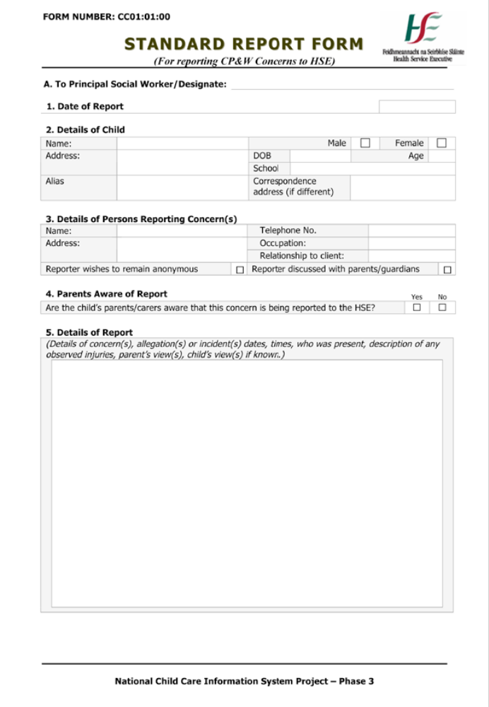

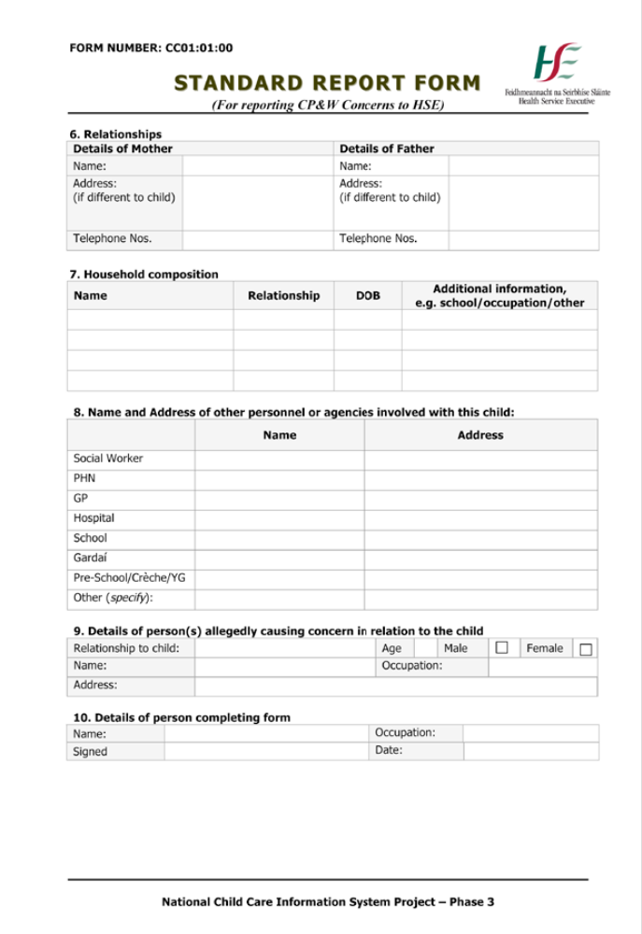

Guidance Notes

The HSE has a statutory responsibility under the Child Care Act, 1991, to promote the welfare and protection of children in their area. The HSE therefore has an obligation to receive information about any child who is not receiving adequate care and/or protection.
This reporting form is for use by:
- Any professional, individual or group involved in services to children, including HSE personnel, who becomes aware of a child protection or welfare concern, or to whom a child protection or welfare concern is reported.
- Professionals and individuals in the provision of child care services in the community who have service contracts with the HSE.
- Designated Liaison Persons in a voluntary or community agency

Please fill in as much information and detail as is known to you. This will assist the Social Work Department in assessing the level of risk to the child, or the support services required. If the information requested is not known to you, please indicate this by putting a line through the question. It is likely that a social worker will contact you to discuss your report.

The HSE aims to work in partnership with parents. If you are making this report in confidence you should note that the HSE cannot guarantee absolute confidentiality for the following reasons:
- A Court could order that information be disclosed.
- Under the Freedom of Information Act, 1997, the Freedom of Information Commissioner may order that information be disclosed.
You should also note that in making a ‘bona fide report’ you are protected under the Protection for Persons Reporting Child Abuse Act, 1998.

If you are unsure if you should report your concerns, please telephone the HSE duty social worker and discuss your concerns with them. (See below).

National Contact Details for HSE Children and Family Services

Also listed on HSE website (www.hse.ie/go/socialworkers) and from HSE LoCall Tel. 1850 241850. These contract numbers may be updated from time to time. Please check HSE websites for latest information.

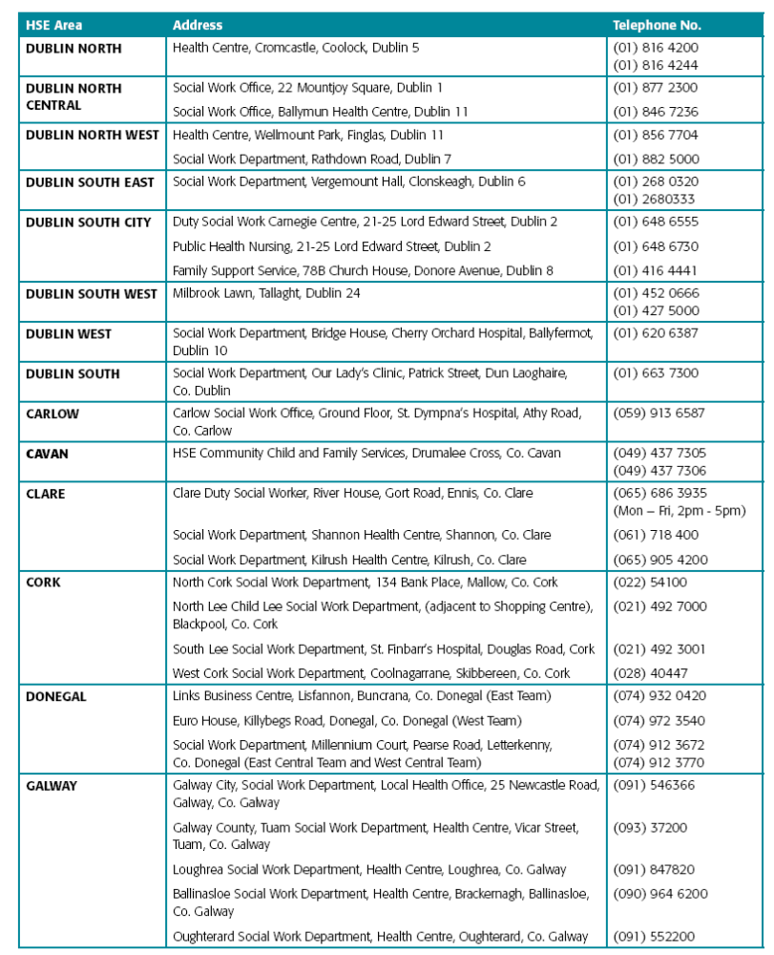
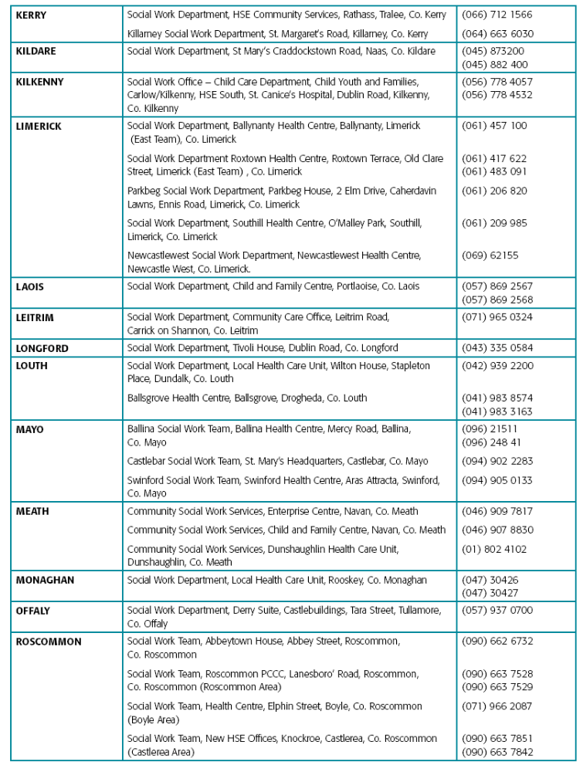

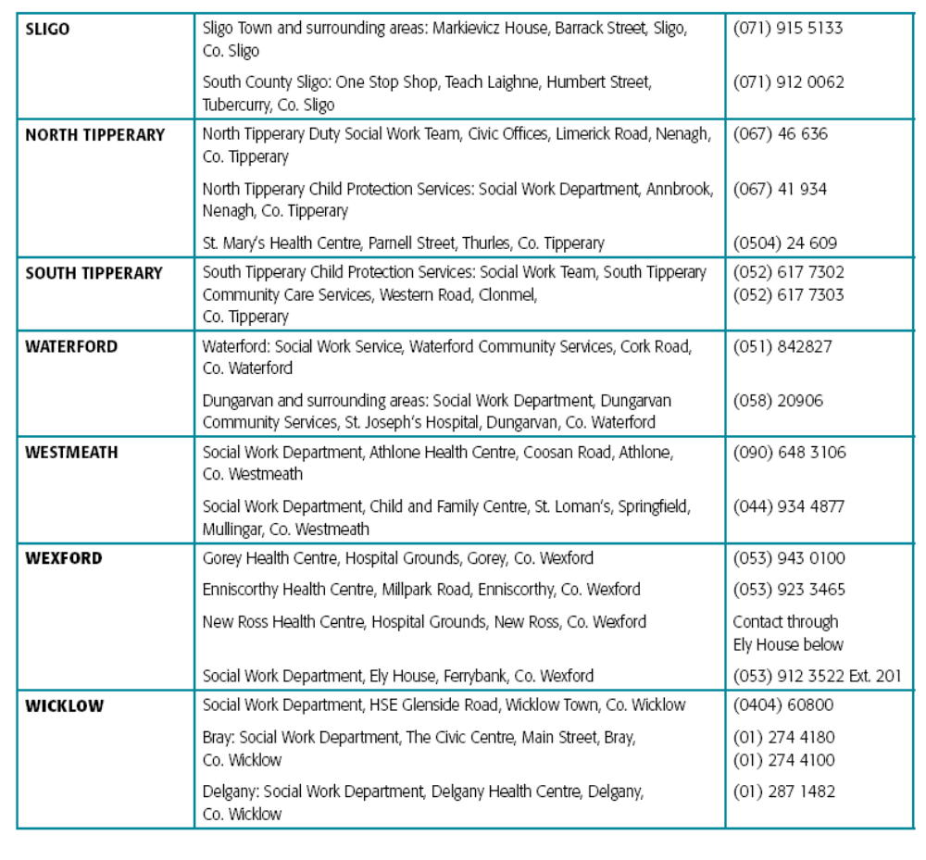

Appendix 4

Guidelines for Responding to a Disclosure

- Be as calm and natural as possible;

- Remember that you have been approached because you are trusted and possibly liked. Do not panic;

- Be aware that disclosures can be very difficult for the child;

- Remember, the child may initially be testing your reactions and may only fully open up over a period of time;

- Listen to what the child has to say. Give them the time and opportunity to tell as much as they are able and wish to;

- Do not pressurise the child. Allow him / her to disclose in their own language and at their own pace;

- Conceal any signs of disgust, anger or disbelief;

- Accept what the child has to say – false disclosures are very rare;

- It is important to differentiate between the person who carried out the abuse and the act of abuse itself. The child quite possibly may love or strongly like the alleged abuser while also disliking what was done to them. It is important therefore to avoid expressing any judgement on, or anger towards, the alleged perpetrator while talking with the child;

- It may be necessary to reassure the child that your feelings towards him / her have not been affected in a negative way as a result of what they have disclosed.

Appendix 5

Protections for Persons Reporting Act, 1998
The Protection for Persons Reporting Child Abuse Act, 1998 provides immunity from civil liability to persons who report child abuse “reasonably and in good faith” to the HSE or and Garda Siochána. This means that, even if a reported suspicion of child abuse proves unfounded, a plaintiff who took an action would have to prove that the reporter had not acted reasonably and in good faith in making the report.
Its main provisions are:
- The provision of immunity from civil liability to any person who reports child abuse “reasonably and in good faith” to designated officers of Health Boards or any member of the Garda Siochána;
- The provision of significant protections for employees who report child abuse. These protections cover all employees and all forms of discrimination up to and including, dismissal;
- The creation of a new offence of false reporting of child abuse where a person makes a report of child abuse to the appropriate authorities “knowing that statement to be false”. This is a new criminal offence designed to protect innocent persons from malicious reports.
However, where a person reports abuse or makes a complaint their anonymity cannot be guaranteed and their identity may be revealed as part of investigations and considerations by the HSE, an Garda Siochána and the Courts.

Appendix 6

Volunteer Application and Declaration Form
(This form should be accompanied by two forms of identification including one photo ID)

First Name/s: Surname:

Address:

Date of Birth: Tel. No. Email address:

Please outline your experience of voluntary work:

Please provide names and addresses of two people (who are not related to you) whom we can contact for a reference:
Name: Name:

Address: Address:

Tel: Tel:

Are you willing to participate in Keeping Safe / Children First training? YES NO

Will you read and implement our child protection policies and procedures? YES NO

Do you agree to read and abide by our Confidentiality policy YES NO

DECLARATION OF SUITABILITY TO WORK WITH CHILDREN / YOUNG PEOPLE

I _________________________ hereby declare that there is no reason known to me and there are no convictions, claims or complaints (past or pending) against me relating to children or young people that would deem me to be unsuitable to work with children / young people and carry out my role within Clones Family Resource Centre Ltd.

Should any criminal charges be made against me, whilst I am associated with Clones Family Resource Centre Ltd., I undertake to immediately inform the Chairperson.

I understand that making a false declaration would be grounds for terminating my voluntary work with Clones Family Resource Centre Ltd.

I give permission to Clones Family Resource Centre Ltd. to vet me with the Garda Central Vetting Unit.

Signed: Date:

Appendix 7

Volunteer Reference Form (adapted from Our Duty to Care)

Name of Volunteer _____________________________________
has expressed an interest in becoming a volunteer with the Family Resource Centre and has given your name as a referee.

- I enclose information on the Family Resource Centre and volunteer job description
- This post involves substantial access to children.
- Do you have any reason at all to be concerned about this volunteer being in contact with children or young people?

Yes No

If you have answered yes, we will contact you by phone or in writing.

If you are happy to complete this reference, all information other than for reasons of child protection and court order, will remain confidential. Information will only be shared with the applicant’s supervisor, should they be offered a volunteer position.

How long have you known this person?

In what capacity?

What attributes do you think that this person has which makes them a suitable volunteer for the post outlined above? Please consider attributes like sense of responsibility, maturity, trustworthiness and reliability in your response.

Signed:

Date:

Occupation:

Appendix 8
Clones Family Resource Centre Ltd.
Comment / Complaint Form

YOUR DETAILS

Name: ____________________________________________________________

Address: ____________________________________________________________

Telephone: ______________________________________
You do not have to provide us with your telephone number but it will be easier for us to get in touch if you do.

NATURE OF YOUR COMMENT / COMPLAINT

What is your comment / complaint about?

________________________________________________________________________

________________________________________________________________________

When did what you are commenting on / complaining about take place?

________________________________________________________________________

________________________________________________________________________

Give details of your comment / complaint
e.g. Background / what you think the Centre failed to do or did wrongly / how you suffered as a result

________________________________________________________________________

________________________________________________________________________

________________________________________________________________________

________________________________________________________________________

Signature: ______________________________________ Date: ___________________

Appendix 9

Incident / Accident Report Form

Event / where the incident / accident occurred___________________________________

Date__________________________________

Location______________________________________

Brief description of what happened___________________________________________

________________________________________________________________________

________________________________________________________________________

Who was involved? ________________________________________________________

Name and contact details for any witnesses_____________________________________
________________________________________________________________________
________________________________________________________________________

Any injury sustained / damage done to property? ________________________________
________________________________________________________________________
________________________________________________________________________

Who dealt with the situation? ________________________________________________

How was it resolved / dealt with? _____________________________________________

________________________________________________________________________

Any follow up required? ____________________________________________________

________________________________________________________________________

Additional information _____________________________________________________

________________________________________________________________________

________________________________________________________________________

Signature________________________________________________________________

Name (Block letters) _______________________________________________________

Appendix 10
Parental / Guardian Consent Form
For participation in (activity / programme / club):
Location:
Transport information (if relevant):
Date(s):

Name of child: ___________________________________________________________ Address: _______________________________________________________________________________________________________________________________________
Date of birth: ______________________Email:_________________________________
Home tel: ___________________Mobile:________________________ Sex M F

Other relevant information:
(Please mention any medical conditions, allergies, special needs or dietary requirements)
________________________________________________________________________________________________________________________________________________________________________________________________________________________

Contact details for parent / guardian
Name: __________________________________________________________________
Address: _______________________________________________________________________________________________________________________________________
Email: _________________________Home tel: _____________Mobile:______________

Other contact person in case of an emergency (different to the person listed above)
Name__________________________________________________________________Address:_______________________________________________________________________________________________________________________________________Home tel:____________________________Mobile:_____________________________
In case of medical emergency:
In the event of illness or accident, I give permission for medical treatment to be administered by a suitably qualified practitioner and / or hospital. I understand that every effort will be made to contact me as soon as possible.

I agree to allow the child named to participate in ________________________________ I understand that there will be suitable supervision while the young people are in the care of Clones Family Resource Centre Ltd. I agree that s/he will be under the authority of, and answerable to, the staff and volunteers of the Family Resource Centre.

I give my consent for my child to be photographed / videoed as I understand that the proceedings may be photographed / videoed and used for promotional purposes by Clones Family Resource Centre Ltd.

Name of family doctor: ____________________________________________________
Address: ________________________________________________________________
Telephone: _______________________________________________

Facebook
I agree to allow my child to go onto the Facebook social network during the Youth Club meeting in Clones Family Resource Centre Ltd. Please note that to join Facebook; an online form must be completed stating that they are over 13 years of age.
Clones Family Resource Centre Ltd. operates an online internet security system and internet access on the computers in the Centre is supervised.

This Consent form will be shared within Clones Family Resource Centre Ltd. on a “need to know basis”. If you do not fully understand any of the questions, need further information or wish to discuss any of your answers it is most important that you contact the Family Resource Centre immediately.

Signed: _______________________________ Name: _____________________________
(Guardian) (Block letters)

Relationship to child: ________________________________________________

Signed: _____________________________________
(Child)

Date: _________________________

Appendix 11

Acknowledge

I, the undersigned, acknowledge that I have read and understood this Child Protection Policy, I understand that the content may be subject to periodic change or review and I will be notified accordingly.

Signed
______________________________________________
Position
______________________________________________
Date of Commencement of Employment
_____/_____/_____

