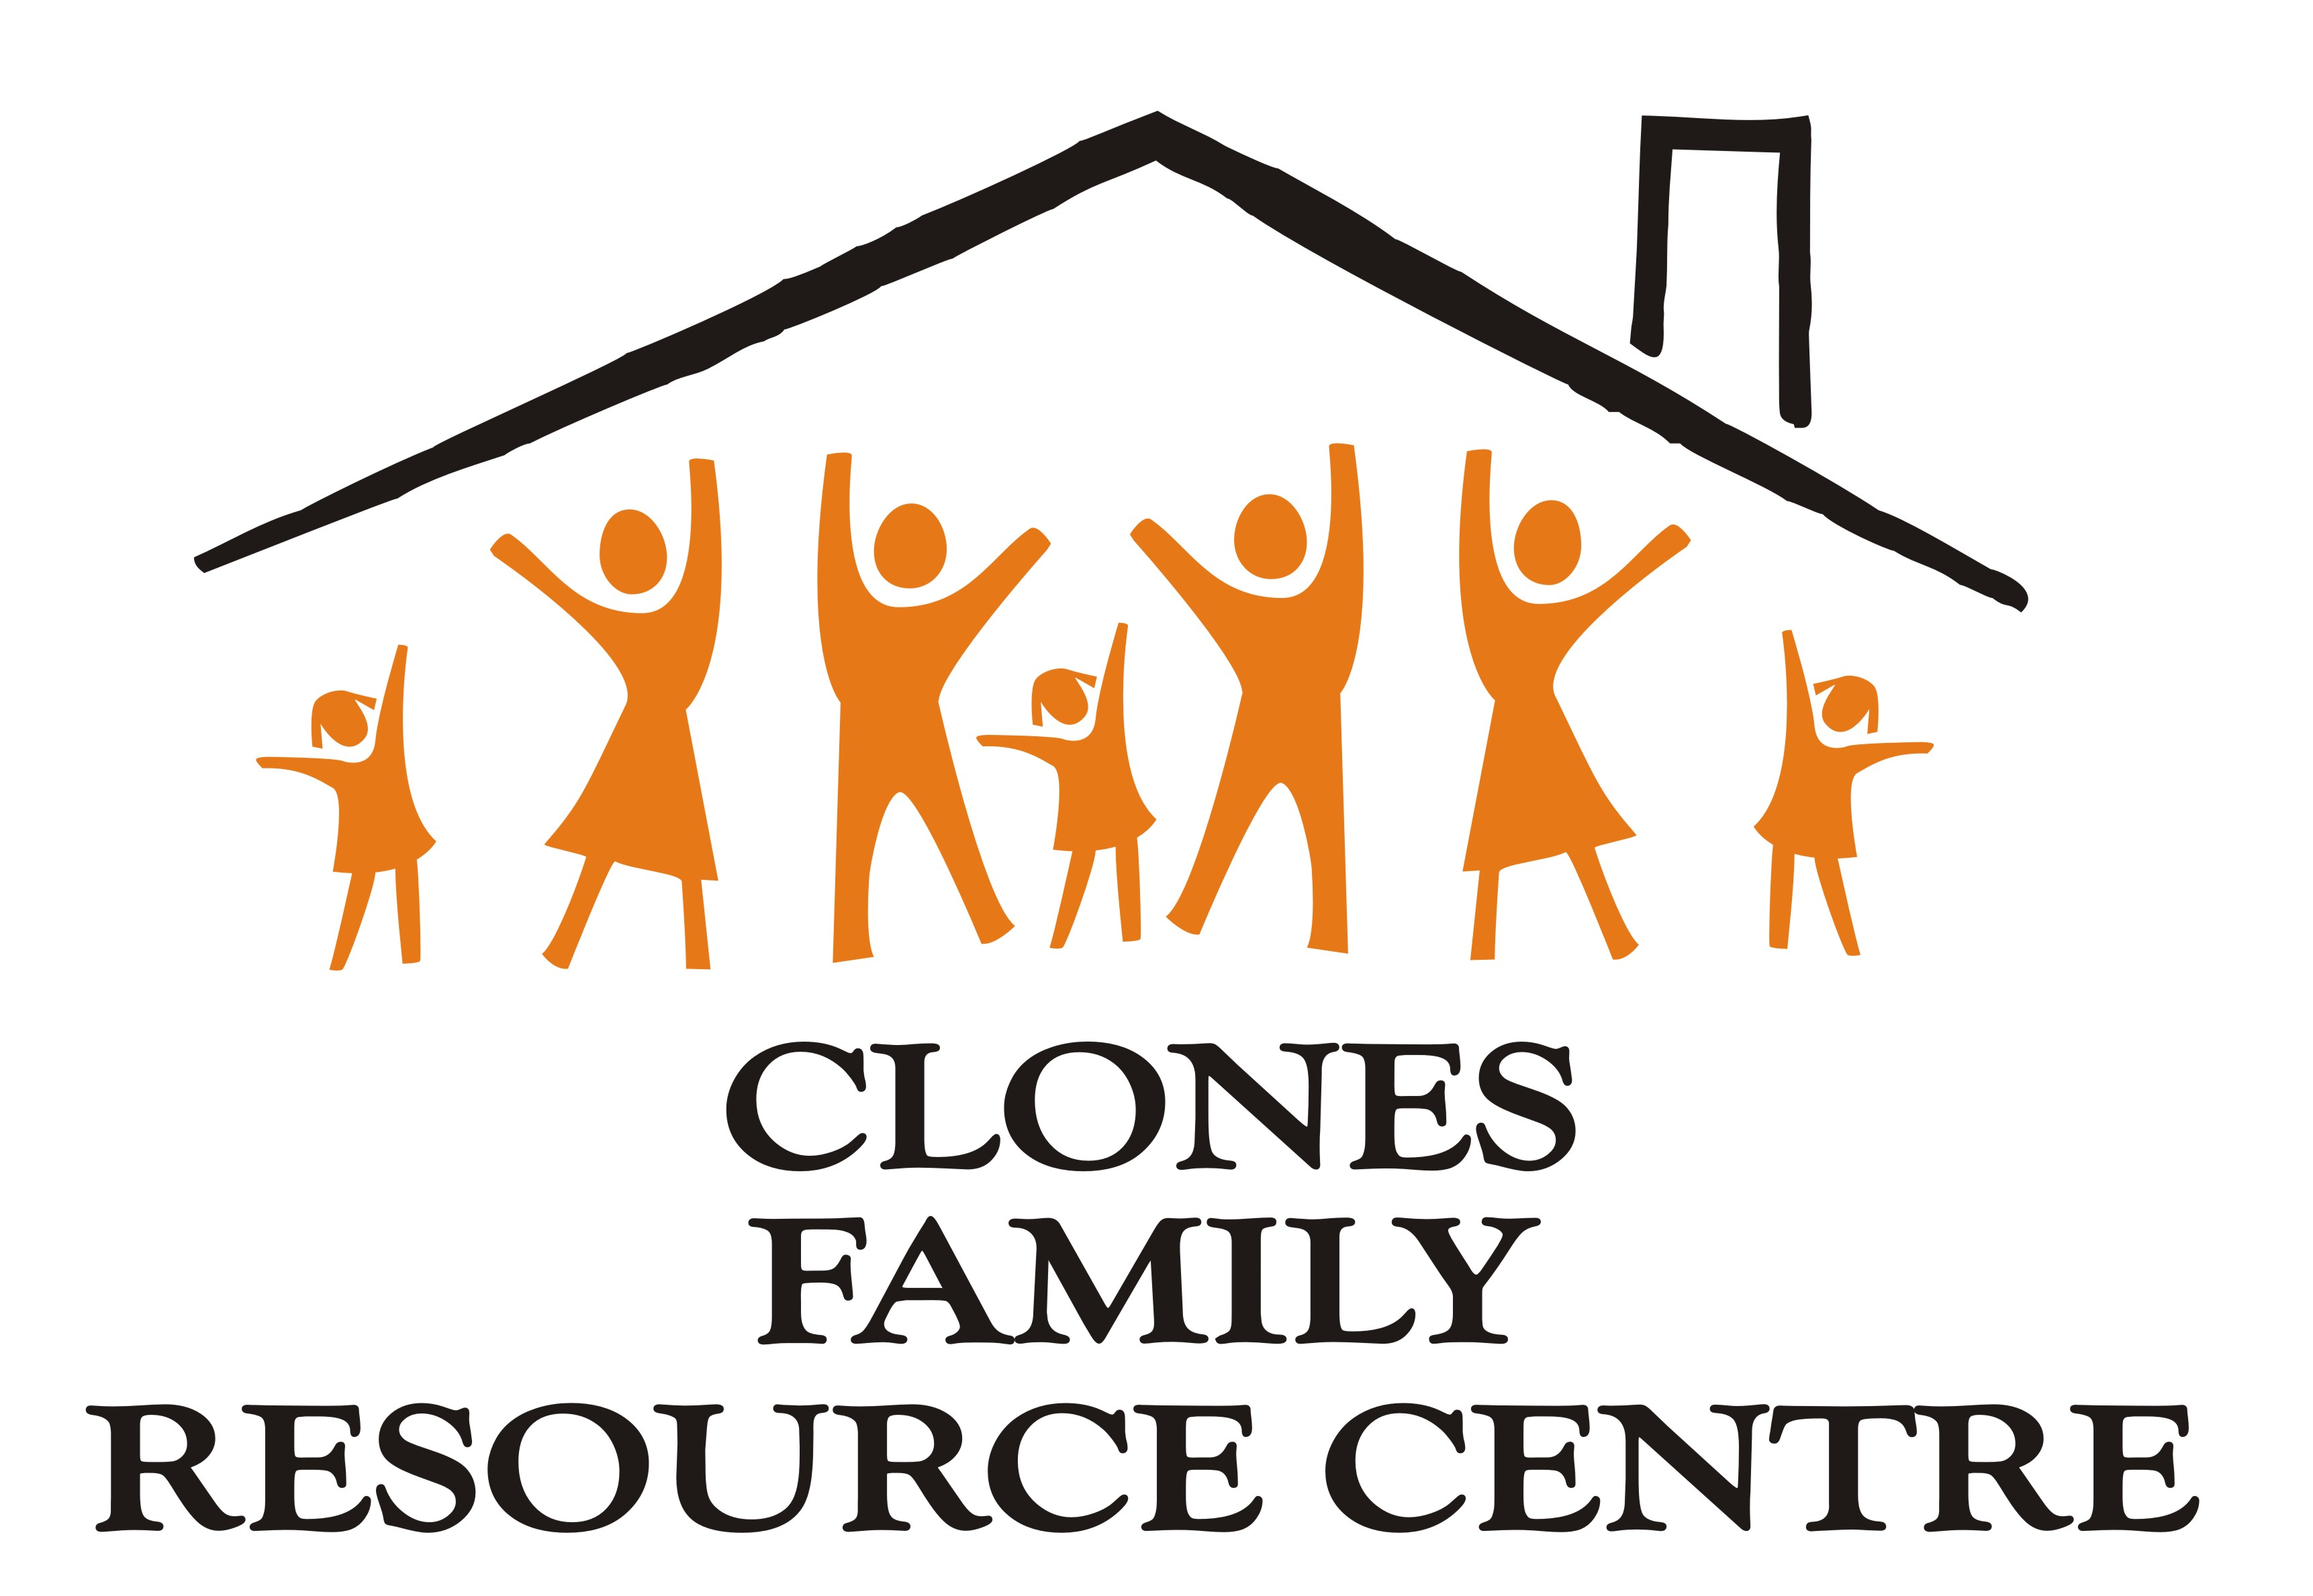


Clones Family Resource Centre is seeking to fill the following position, based in Clones, County Monaghan

Social Inclusion Officer (RESTART Programme)

This full-time role requires organisational, interpersonal and communication skills, with the ability to work on a cross-border basis with diverse groups.

- Salary: €48,000 per annum, (Grade 5 HSE)
- Hours: Full time with flexibility for evenings / weekends
- Closing date for applications: 27 February 2026 at 5 pm
- Interview date: 19 March 2026 (provisional)

To request an information pack email recruitment@clonesfrc.ie

This project is supported by PEACEPLUS, a programme managed by the Special EU Programmes Body – SEUPB

